INDEPENDENT EVALUATION DIVISION

Independent Evaluation

GEF UNIDO Cleantech Programme for SMEs in South Africa
UNIDO SAP ID: 130129
GEF Project ID: 5515

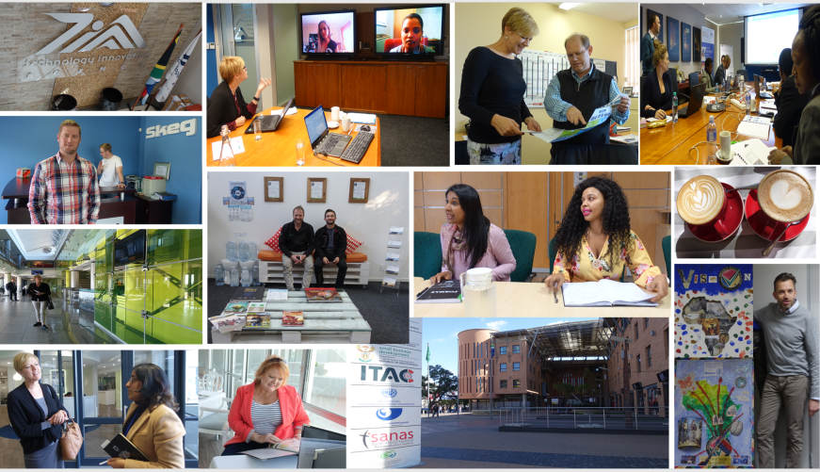



UNIDO INDEPENDENT EVALUATION DIVISION

Independent Evaluation

GEF UNIDO Cleantech Programme
for SMEs in South Africa

UNIDO SAP ID: 130129
GEF Project ID: 5515



Vienna, July 2018

Distr. GENERAL
XXXXXXXX

July 2018

Original: English

This evaluation was managed
by the responsible
UNIDO Project Manager with quality assurance by the Independent Evaluation Division

The designations employed and the presentation of the material in this document do not imply the expression of any opinion whatsoever on the part of the Secretariat of the United Nations Industrial Development Organization (UNIDO) concerning the legal status of any country, territory, city or area or of its authorities, or concerning the delimitation of its frontiers or boundaries.

Mention of company names and commercial products does not imply the endorsement of UNIDO.

The views and opinions of the team do not necessarily reflect the views of the Governments and of UNIDO.

This document has not been formally edited.

Table of Contents
Acknowledgements v
Abbreviations and acronyms vi
Glossary of evaluation-related terms vii
Map of GEF-UNIDO Cleantech Programme for SMEs in South Africa viii
Executive Summary 1
1 Evaluation Objectives, Methodology, Process 5
1.1 Introduction and Background on the Terminal Evaluation 5
1.2 Objectives and Scope of the Terminal Evaluation 5
1.3 Evaluation Methodology 5
1.4 Challenges and Limitations 6
2 Country and Project Background 7
2.1 Country Background 7
2.2 Sector-Specific Issues of Concern to the Project 7
2.3 Project Summary 10
2.3.1 Background 10
2.3.2 Project Objective and Structure 11
2.3.3 Project Partners and Implementation Arrangements 12
2.3.4 Positioning of the UNIDO Project 13
2.3.5 Milestones in Project Design and Implementation 13
3 Project Assessment 15
3.1 Progress-to-Impact 15
3.2 Project Design 20
3.2.1 Overall Design 20
3.2.2 Logframe and Reconstructed Theory of Change 21
3.3 Project Performance 24
3.3.1 Relevance 24
3.3.2 Effectiveness 25
3.3.3 Efficiency 30
3.3.4 Sustainability of Results and Benefits 31
3.4 Assessment of Cross-Cutting Performance Criteria 35
3.4.1 Gender Mainstreaming 35
3.4.2 M & E System 36
3.4.3 Results-based Management (RBM) 38
3.5 Performance of Partners 38
3.5.1 UNIDO 38
3.5.2 National Counterparts 39
3.5.3 Donor 39
3.6 Processes affecting achievement of project results 39
3.6.1 Preparation and readiness / quality at entry 39
3.6.2 Financial Planning 40
3.6.3 Effect of Co-Financing on Project Outcomes and Sustainability 41
3.6.4 Implementation approach 41
3.7 Other Assessments Required for GEF-Funded Projects 42
3.8 Overarching Assessment and Rating Table 43
4 Conclusions, Lessons Learned, Recommendations 45
4.1 Conclusions 45
4.2 Lessons Learned 48
4.3 Recommendations 49
Annex 1. Evaluation ToR 52
Annex 2. List of Documents Reviewed 52
Annex 3. List of Respondents 56
Annex 4. Summary of Project Identification and Financial Data 59

Table 1: Summary of GCIP Project’s Evaluation Ratings 3
Table 2: Financing Inputs by Source (planned), 2013-2016 11
Table 3: Milestones and Key Dates in Project Implementation 13
Table 4: Overview of Project's Progress in Meeting its Overall Objective 16
Table 5: Evidence of Scaling Up Across South Africa 17
Table 6: Projected GHG Emission Reductions Generated by Sampling of South African Innovations 19
Table 7: Social Inclusiveness Achievements (2014-2017) 20
Table 8: Examples of Formulations of Outcomes to Support Achievement of Impact 22
Table 9: Summary of Project's Success in Producing Outputs under Outcome 1 26
Table 10: Summary of Project's Success in Producing Outputs under Outcome 2 28
Table 11: Summary of Project's Success in Producing Outputs under Outcome 3 29
Table 12: Expansion of Competition-Accelerator to Include Additional Sectors (2014 -2018) 31
Table 13: Budgeting and Funding for M&E Activities 38
Table 14: Year-Wise Project Expenditures by Outcome (January 2014 to December 2017) 41
Table 15: Co-Financing from South African Partners (planned) 41
Table 16: Summary of Findings and Ratings by Evaluation Criteria for GCIP South Africa Project 44

Figure 1: Explosion in Support available for South African Entrepreneurs and Startups (2017) 8
Figure 2: State of South Africa’s National Entrepreneurship Support System (2018) 9
Figure 3: Motivations for Entrepreneurship in South Africa, 2017 Survey 10
Figure 4: Project Implementation Arrangement 12
Figure 5: Reconstructed Theory of Change - GCIP South Africa Project 23
Figure 6: Project Performance in Channelling Startups through its Innovation Funnel: 2014-2017 27
Figure 7: Sustaining Impact in Environmental Safeguarding and Social Inclusiveness (2018) 32

Picture 1: GCIP’s Geographical Outreach in South Africa (2011-2018) viii
Picture 2: Presentation of Preliminary Findings to Project Steering Committee, 29 May 2018 37

Acknowledgements
The Evaluation Team engaged to undertake this independent terminal evaluation of the “GEF UNIDO Cleantech Programme for SMEs in South Africa” (GCIP South Africa) would like to express sincere appreciation to acknowledge and thank the project’s partners, counterparts, start-ups, mentors, judges, and other actors interviewed in Pretoria, Johannesburg, Cape Town, Durban, and Port Elizabeth during the field mission (May-June 2018).
Appreciation is extended to Evaluation Officer Ms. Thuy Thu Le and Project Manager Mr. James New in Vienna, the implementation team in Pretoria: National Project Coordinator Mr. Gerswynn Mckuur, Petro de Wet (Senior Communications Expert), Mr. Conrad Kassier (Technical Project Expert), and Ms. Nikola Niebuhr (Project Assistant), and the team in the Technology Innovation Agency (TIA) who have tirelessly worked to support and transition the GCIP concept into the country’s political fabric.
The Evaluation Team conveys its gratitude to all those who provided input into this terminal evaluation of the GCIP’s implementation in South Africa. The quality of their reflection has facilitated the development of robust findings, lessons learned, and recommendations, which are offered with the aim of guiding and informing the architecture and implementation of projects within the domain of cleantech innovation, and beyond.

Ms. Joyce Miller, Team Leader and International Evaluation Consultant
Ms. Betsy Ings, National Evaluation Consultant

Abbreviations and acronyms
COP (UN Climate Change) Conference of the Parties
CSIR (South Africa) Council for Scientific and Industrial Research
CTO Cleantech Open
DoE (South Africa) Department of Energy
DST (South Africa) Department of Science and Technology
DTI (South Africa) Department of Trade and Industry
EU European Union
ICT Information & Communications Technologies
GCII Global Cleantech Innovation Index
GCIP Global Cleantech Innovation Programme
GDP / GNI Gross Domestic Product / Gross National Income
GEF Global Environment Facility
KPI Key Performance Indicator
M&E Monitoring and Evaluation
MoU Memorandum of Understanding
NCPC-SA National Cleaner Production Centre of South Africa
ODG/EVQ/IEV UNIDO Office for Independent Evaluation
PIR Project Implementation Report
R & D Research and Development
RBM Results Based Management
RECP Resource Efficient Cleaner Production
SADC South African Development Community
SDG(s) Sustainable Development Goal(s)
SME(s) Small- and Medium-Sized Enterprise(s)
TE Terminal Evaluation
TIA Technology Innovation Agency
TOC, RTOC Theory of Change, Reconstructed Theory of Change
ToR Terms of Reference
UNDP United Nations Development Programme
UNIDO United Nations Industrial Development Organisation
US(D) United States, US dollar

Glossary of evaluation-related terms
Term | Definition
Baseline | The situation, prior to an intervention, against which progress can be assessed.
Effect | Intended or unintended change directly or indirectly due to an intervention.
Effectiveness | The extent to which the development intervention’s objectives were achieved or are expected to be achieved.
Efficiency | A measure of how economically resources/inputs (funds, expertise, time, etc.) are converted to results.
Impact | Positive & negative, intended & non-intended, directly & indirectly, long term effects that represent fundamental durable change in the condition of institutions, people & their environment brought about by the Project.
Indicator | Quantitative or qualitative factors that provide a means to measure the changes caused by an intervention.
Intermediate States | The transitional conditions between the Project’s outcomes & impacts which must be achieved in order to deliver the intended impacts.
Lessons learned | Generalizations based on evaluation experiences that abstract from the specific circumstances to broader situations.
Logframe (logical framework approach) | Management tool drawing on results-based management principles used to facilitate the planning, implementation and evaluation of an intervention. It involves identifying strategic elements (activities, outputs, outcomes, impacts) and their causal relationships, indicators, and assumptions that may affect project success or failure.
Outcomes | The likely or achieved short- to medium-term behavioural or systemic effects to which the Project contributes, which help to achieve its impacts.
Outputs | The products, capital goods, and services that an intervention must deliver to achieve its outcomes.
Relevance | The extent to which an intervention’s objectives are consistent with beneficiaries’ requirements, country needs, global priorities and partners’ and donor’s policies.
Risks | Factors, normally outside the scope of an intervention, which may affect the achievement of an intervention’s objectives.
Sustainability | The continuation of benefits from an intervention, after the development assistance has been completed.
Target groups | Specific entities for whose benefit an intervention is undertaken.

Map of GEF-UNIDO Cleantech Programme
for SMEs in South Africa

Picture 1: GCIP’s Geographical Outreach in South Africa (2011-2018)

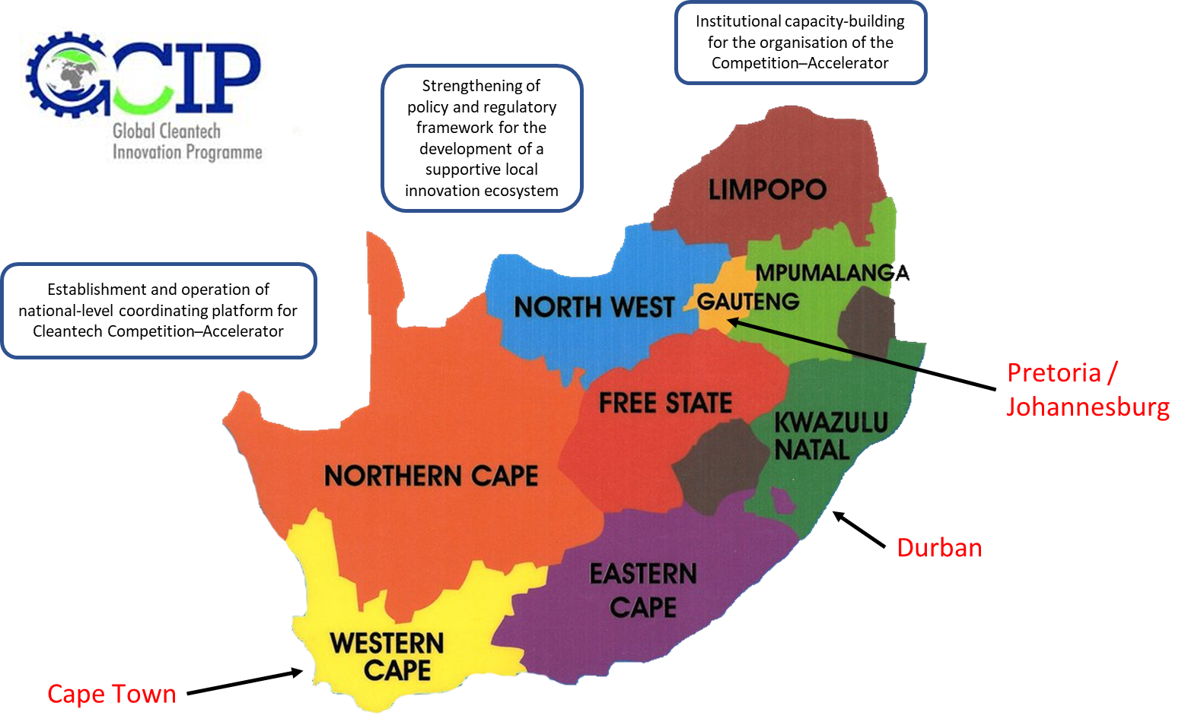

Executive Summary
Evaluation Background and Methodology
This document is the Terminal Evaluation (TE) Report on the “Cleantech Programme for SMEs in South Africa” (hereafter, GCIP-SA) initiated in October 2013 for 36 months (extended to 30 September 2018) with Global Environment Facility (GEF) support, implemented by UNIDO together with South Africa’s Department of Industry and Trade (DTI)’s Innovation Technology Agency (TIA). The project’s design and performance were assessed in terms of progress-to-impact relevance, effectiveness, efficiency, and sustainability of benefits to meet accountability requirements and promote learning knowledge sharing to enhance future project design and implementation. Carried out during May-July 2018 by an independent team, the TE consisted of i) desk review of relevant documentation; ii) assessment of project design, including a reconstruction of its Theory of Change; iii) field inquiry with stakeholder meetings in Pretoria, Johannesburg, Cape Town, Durban, Port Elizabeth); and iv) analysis and development of evidence-based findings and recommendations.
Summary of the Main Evaluation Findings
Progress-to- Impact
The project incorporated economic and social safeguards and tangibly contributed to global environmental benefits. A positive unintended effect relates to enabling the national host to strengthen its own services and institutional role as a bridge for innovation, research and development. Further evidence of impact was evident in replication and scaling up, albeit nascent. Gender mainstreaming and social inclusiveness efforts were strengthened mid-way. Overall, the intervention did not yet engage the volume of startups envisaged to benefit from the process. Efforts to mainstream project results into broader stakeholder mandates need further time to be realised.
Project Design
The design was based on a template with three substantive components, underpinned by continuous monitoring and evaluation to assure smooth implementation. The approach was conceptually sound, well-resourced, with a legitimate governance structure. More attention to the choice of indicators/targets and definitions to ensure common understanding and allow for comparison across GCIP pilots would have significantly strengthened the logframe and better guided the implementing team and M&E system. Notions representing important catalytic potential were not referenced and no project activities appeared to provide the scope for creating and leveraging such linkages.
Relevance
The project was highly pertinent to international/regional/national priorities, the needs and interests of its beneficiaries, fully aligned with donor priorities, and well-suited to UNIDO’s mandate, competences, and strategy for Inclusive and Sustainable Industrial Development. It bridged a gap by providing support to nurture early-stage startups along a path to maturity and formal establishment.
Effectiveness
The project ran 4 annual cycles of the Competition-Accelerator (above target) although its ability to attract and channel the planned number of startups into this “innovation funnel” was impacted by a maladapted application process, which proved a high barrier to entry, with an average 55% attrition rate. Teams that persevered with innovations at a sufficient level of readiness greatly benefitted from business development and early stage nurturing, which enabled some to tap further resources (although this was not systematically tracked). During the project period, 12 teams were active in the market; the extent to which their commercialisation could be attributed to the project was not easy to gauge. While the GCIP’s envisaged national coordination role was not clearly defined, the PMU undertook to involve numerous institutions, supporting the notion of creating a wide platform. A policy study and follow-up survey were mandated. Findings shared in a multistakeholder context fed PSC discussion to determine next steps. Outreach to share the project experience with neighbouring countries has provided initial ground for extension to the wider SADC region.
Efficiency
Like other pilot projects operating under the GCIP framework, the project’s duration was extended (by 23 months), which meant that its originally allocated resources were stretched over 59 months. Embedded within the national host, the project benefitted from TIA’s existing infrastructure, on-the-job training opportunities, further support available from UNIDO’s Regional Office nearby in Pretoria.
Sustainability of Results and Benefits
The PMU did an excellent job in conceiving and implementing an exit strategy before project closure, which has assured that the GCIP’s results have been institutionalised and national ownership has been secured, with an associated budget linked to a Business and Operations Plan for 2018-2021. The project positively contributed to many priorities of national stakeholders and can be expected to continue to engage the interest and support of the PSC members, moving forward under TIA’s auspices. The socio-political context in which the project is embedded has evolved positively with President Ramaphosa’s election, providing optimism regarding the continuation of benefits. Further resourcing is urgently needed during the transition period (and likely beyond) to maintain reputation/quality/impact and expand efforts, together with further efforts to develop local GCIP training capacity and assure continued (volunteer?) participation of key ecosystem support actors.
Gender Mainstreaming
Given the importance of gender mainstreaming to national/international priorities, the project made a slow start on realising intended achievements, although well-intentioned. Social inclusiveness efforts improved over time. A more strategic approach was under design at the time of the TE.
Monitoring and Evaluation (M & E)
UNIDO’s standard M&E approach was designed, adequately resourced, and implemented. The PMU’s monitoring activities were overseen by the PSC, which annually reviewed project progress. UNIDO headquarters effectively oversaw and supported the project, monitoring the intervention through regular visits, stakeholder consultations, and progress reporting.
Results-Based Management
The project teams in Vienna and Pretoria maintained focus on progressing activities, outputs, targets according to the project’s results framework, which drove the M&E system design. Specific attention was paid to recording statistics related to the Competition-Accelerator, which was very much in the foreground (i.e. received applications, eligible applications, semi-finalists, female-led team, mentors, business clinics, technology innovations of startups), which overshadowed a focus on outcomes.
Performance of Partners
UNIDO carried out its duties in a responsible manner. GEF’s contribution played a catalytic role through the GCIP for further development of South Africa’s innovation ecosystem. The national host TIA significantly strengthened its convenor role and the project was well-supported by PSC members.

Other Assessments Required for GEF-Funded Projects
No instances of financial mismanagement that require a follow-up were detected. The project more than adequately incorporated environmental, economic, and social safeguards. The substantial co-financing amounts estimated at the planning stage were not tracked and are assumed to not have materialised to the expected levels. In-kind contributions from private sector actors (technical partners, mentors, judges, local trainers-in-training) were extremely important in realising the project’s impacts. As in other GCIP pilot countries, questions about the suitability of the CTO platform/Silicon Valley culture for the emerging/developing country context were brought forward, as well as concerns regarding intellectual property; storage, use, and access to gathered data, and the extent of reliance on external support for training inputs beyond the pilot phase. Without support on partner qualification, startups under the GCIP framework appear vulnerable to potential exploitation by other actors with privileged information and relationships. These point to higher level governance issues that need to be resolved by UNIDO and GEF, moving forward.

Rating of Project Performance
Overall, the project is rated as “satisfactory”. Table 1 provides an overview of the ratings.
Table 1: Summary of GCIP Project’s Evaluation Ratings
Criterion | Rating
A. Progress-to-Impact | S
B. Project Design | S
- Overall Design | HS
- Logframe | MS
C. Project Performance
- Relevance | HS
- Effectiveness | S
- Efficiency | S
- Sustainability of Results and Benefits | L
D. Cross-Cutting performance criteria
- Gender Mainstreaming | S
- M & E | S
- Results-Based Management (RBM) | S
E. Performance of partners
- UNIDO | HS
- National Counterparts | HS
- Donor | HS
F. Overall assessment | S

Summary of Lessons Learned and Recommendations
Several lessons have been extracted from the GCIP-SA experience to inform future project design and implementation:
Lesson #1: Engaging the “right” institutional host is key to a natural path and transition to full national ownership, best executed before project closure to boost sustainability of project results and benefits.
Lesson #2: There is a limited extent to which a medium-sized project with confined budget and timeline can carry out too broadly-scoped policy strengthening ambitions and mainstream lessons and results.
Lesson #3: Stimulating and supporting innovation through business acceleration can be expanded to further sectors, therein fostering an entrepreneurial mindset seen as key to unleashing creativity, seeing new ways of doing things, and meaningfully contributing to solving challenges and generating opportunities that enhance environmental protection, economic competitiveness, and job creation.
Lesson #4: Project design informed by updated insights about the context in which an intervention is embedded and attention in the corresponding results framework to the choice and formulation of outcomes/targets/indicators are vital to drive towards impact, orient the M&E system, effectively guide the implementing team, and serve as a useful baseline reference for project evaluation at closure.

The Evaluation Team would also like to offer some recommendations to support the project’s current transition to full national ownership, which may also be relevant for other initiatives at the same stage.

Recommendation #1: Ensure adequate resourcing is in place in the short-term to maintain reputation, quality, and impact and avoid potential staff burnout and attrition.
Recommendation #2: Review the strategy of pursuing voluntary participation of key ecosystem support actors to assure the endeavour’s quality and reliability and adequate development of local training capacity to independently carry out the Competition-Accelerator in future.
Recommendation #3: Strengthen efforts in gender mainstreaming and social inclusiveness, which support national priorities and have been observed to increase the intervention’s desired impacts.
Recommendation #4: Leveraging TIA’s convenor role within the national ecosystem, clarify and undertake the national coordinating role envisaged by the GCIP framework to dynamize and engage other ecosystem actors in supporting alumni and “fallen heroes” on their respective development journeys.

These lessons and recommendations are elaborated in more detail in the Report’s final chapter, which provides further context and linkages to the conclusions which were drawn from the assessment in which these are embedded.

Evaluation Objectives, Methodology, Process

Introduction and Background on the Terminal Evaluation
- Following the perceived relevance of a concept piloted during COP17 in 2011, the “GEF UNIDO Cleantech Programme for SMEs in South Africa” (hereafter, GCIP-SA) was launched as a 3-year project in October 2013 by UNIDO and national host Technology Innovation Agency (TIA) under South Africa’s Department of Trade and Industry (DTI), in collaboration with the Council for Scientific and Industrial Research (CSIR), Department of Environmental Affairs (DEA), Department of Science and Technology (DST), and other partners.
- Following UNIDO Evaluation Policy and GEF Monitoring and Evaluation Policy, this Terminal Evaluation (TE) was carried out during May-July 2018 by an independent team: Ms. Joyce Miller as team leader/international consultant and national consultant Ms. Betsy Ings.

Objectives and Scope of the Terminal Evaluation
- Guided by Terms of Reference given by UNIDO (see Annex 1), this evaluation had 2 objectives:
- Assess project performance in terms of its progress to impact, relevance, effectiveness, efficiency, and sustainability of benefits
- Develop findings, lessons, and recommendations that could be used to enhance the design of new projects and implementation of ongoing projects by UNIDO
- In terms of scope: the TE covers the project’s duration from 21 October 2013 to 30 September 2018 (including a 23-month “no cost” extension). The TE assessed the extent to which the project achieved its main purpose (to promote South Africa’s innovation ecosystem and accelerate the establishment of innovative clean energy technology for small- and medium-sized enterprises (SMEs). In this light, the TE considered the extent to which the Clean Energy Technology Innovation Competition and Entrepreneurship Accelerator Programme (hereafter, the Competition-Accelerator) was a suitable instrument for achieving the project’s main purpose.
- Gauging sustainability of benefits involved looking into the extent to which the project: i) assisted in identification and early stage nurturing of promising local clean energy technologies; ii) coordinated with relevant actors and existing and planned initiatives to promote clean energy technology innovation and entrepreneurship; iii) facilitated global networking of South Africa’s most promising start-ups with mentors and potential business partners abroad; iv) yielded direct outcomes that are being utilized, or could expect to be used in the near future, to support cleantech startups within a policy framework that fosters a vibrant local innovation ecosystem; v) helped put in place conditions to address drivers and overcome barriers to promoting clean energy technology innovation and entrepreneurship in South Africa.

Evaluation Methodology
- The TE was carried out by an independent team following provided guidance and criteria (see Annex 1) rated using UNIDO’s 6-point scale, with justifications elaborated through the Report.
- The evaluation used a participatory approach where key stakeholders were kept informed and consulted throughout the process. The evaluation team liaised with UNIDO’s Independent Evaluation Division (ODG/EVQ/IEV) on methodological issues and the evaluation’s conduct.
- To assure a robust approach, an evaluation framework was developed, together with envisaged sources of data that could be expected to yield evidence of achieved results and impacts. A primarily qualitative approach was used in gathering data, with the aim of developing insights into the project’s strengths and shortfalls as a basis for crystallizing the findings and extracting relevant lessons for organisational learning and operational improvement.
- Data was collected using multiple means:
- Desk study and literature review: of key project documentation, including the initial approval request, annual work plans, monitoring reports, Project Steering Committee (PSC) minutes, Project Implementation Reports (PIRs), Annual Monitoring Reports (AMRs), project website, studies & presentations, dissemination materials/media reports, relevant correspondence, and other thematic resource materials. See Annex 2.
- Field visit: with direct observation/interviews in Pretoria, Johannesburg, Cape Town, Durban, Port Elizabeth with 60 startups, mentors, judges, technical partners, co-financing partners, UNIDO,
the implementing team, and other interested stakeholders (e.g. other accelerators, potential partners) who could benefit from project results and/or provide future dissemination channels.
- Remote Interviews: were carried out with UNIDO staff in Vienna headquarters and with external innovation experts who provided a general outside view of cleantech innovation acceleration.
- The PMU assisted in identifying and arranging meetings with relevant actors. This consultation of a broad cross-section of stakeholders (see Annex 3) was used to gather a range of perspectives with the aim of deepening understanding, triangulating the data, allowing for emergence of evidence-based conclusions and recommendations, and potential partners. Preliminary findings were presented and discussed during a Project Steering Committee convened on 29 May 2018 in Pretoria.
- Steps were undertaken to enhance stakeholder engagement and the quality of consultation; respondents were: i) informed about the TE’s aims and guided in their input through a semi-structured protocol; ii) engaged in critical reflection in a way that honoured their contribution to the endeavour and sought to energize future contributions; and iii) assured of the anonymity and confidentiality of their input. Well-formulated, open-ended questions and further probes were used to promote balanced contemplation, generate new insights, and yield higher quality data (as opposed to yes/no questions or an ‘audit’ approach), as it was considered that input to this evaluation required contextualisation, complex description, and explanation.

Challenges and Limitations
- While it would have been ideal to have direct input from all actors involved in implementing activities, only a selection of those involved in the project were consulted, given budget and time constraints. These actors were selected with the aim of providing representative perspectives and enabling a balanced assessment of the project’s intended outcomes and impacts.
- Not all evidence regarding outcomes was available at the time this report was prepared. Consequently, the expected outcomes and the extent to which their achievement depended on the delivery of project outcomes was assessed by reconstructing the project’s Theory of Change (RTOC; see Figure 5) and looking at its causal pathways to assess their likelihood of achievement. The RTOC was shared with improved with feedback from the Evaluation Office and project team.

Country and Project Background

Country Background
- With 56 million inhabitants in 2018, the South African economy grew dramatically since the fall of apartheid in 1994. An upper-middle income economy for The World Bank, it has Africa’s 2nd largest economy, overtaken only recently by oil-rich Nigeria. South Africa is one of the continent’s most industrialised with a first-world road/rail/port network and stable and generally sound banking/financial sector. The International Monetary Fund (IMF) expected the economy to recover into 2019. At 1.7%, however, South Africa’s economy is far from its desired 6% growth rate.
- In 1995, the mainstreaming of gender was identified as a key process to institute change in the new South African democracy. Numerous actions have since been undertaken to instantiate gender equality and shine a light on its importance. Still recovering from the enormous wealth inequalities precipitated by apartheid, South Africa has the highest percentage of people living in poverty across OECD countries, at 26.6%. Ranked 119th of 188 countries on UNDP’s Human Development Index (HDI), the data become more understandable by looking at GNI per capita for South African women (8795) versus men (15,489). Ranked 85th of 135 on HDI’s Human Poverty Index, the country’s assessment has slowly improved since 1980. Substandard education, high unemployment, and an oversubscribed welfare system continue to blight the country and trap many of its citizens in poverty. Weak job creation capacity has led to chronically high unemployment, now at an all-time high (27.6%), with youth unemployment at over 65%. Under-employment has been a critical contributor to the country’s persistent poverty and inequality.
- South Africa meets 77% of its energy needs using its abundant coal supplies, putting the country as the world’s 14th highest emitter of greenhouse gases (GHG). Total GHG emissions grew 44% during 1990-2012, with an average annual increase of 1.7% over that period, expected to peak during 2020-2025. South Africa’s GHG profile is dominated by emissions from the energy sector, accounting for 84% of the country’s total emissions in 2012. Breaking this down, 60% were due to electricity/heat, 15% from manufacturing/construction, 12% from transportation, 12% from other energy subsectors. Agriculture is the 2nd highest emitting sector, contributing 7% to total GHG.
- Renewable Energy was introduced through the Integrated Resources Plan (IRP, 2010) to diversify power-generating capacity and involve independent power producers in delivering electricity from renewable resources (e.g. solar photovoltaics, wind farms). About 6.5% of South Africa’s electricity is provided by two nuclear reactors outside Cape Town. Despite the IRP’s efforts to diversify and expand the country’s energy mix, unreliability stemming from various factors (labour unrest, ageing infrastructure, etc.) coupled with the high cost of electricity, have had a negative impact on the industrial sector and negatively impacted business and investor confidence.

Sector-Specific Issues of Concern to the Project
- Statistics South Africa estimated that there were over 2.2 million SMEs in operation, and potentially more given their widespread existence in the informal ‘township’ economy. Former President Thabo Mbeki referred to South Africa as a two-tiered economy: one rivalled other developed countries, while the other had only the most basic infrastructure. Through its 2010 New Growth Plan (which knit together the Industrial Policy Action Plan and policies and programs in science and technology, rural development, agriculture, education/skills development, labour, mining, tourism, social development), the government identified innovation and entrepreneurship as key levers to bridge the divide between previously disadvantaged communities and their more affluent counterparts, and to accelerate economic growth, targeting the creation of 5 million new (more labour-absorbing) jobs by 2020 by drawing on the country’s technological, research, and manufacturing base to generate new processes and products. “Innovative and technology-based SMEs were identified as the fuel to drive local, regional and international growth”.
- At the time of project design (2012), South Africa ranked 28th out of 38 countries surveyed as part of the Global Cleantech Innovation Index (GCII), which identified countries seen as having the greatest potential to produce entrepreneurial start-ups that would commercialise clean technology innovations over the next 10 years.
- Tremendous institutional support was available in terms of enabling legislation, policies, and capacity-building services, with the latter experiencing explosive growth over the previous two years, primarily fuelled by domestic sources including government and non-profit organisations specifically established to grow South African entrepreneurs. In 2017: 340 organisations (a 58% increase since 2015) were identified as providing support to the entrepreneurial ecosystem, with 142 capacity development providers (82% of whom were South African) offering their services to SMEs and a 36.6% increase from 2015 to 97 direct finance providers (80% of whom were South African), offering debt, equity, and grants to small businesses (see Figure 1).
Figure 1: Explosion in Support available for South African Entrepreneurs and Startups (2017)
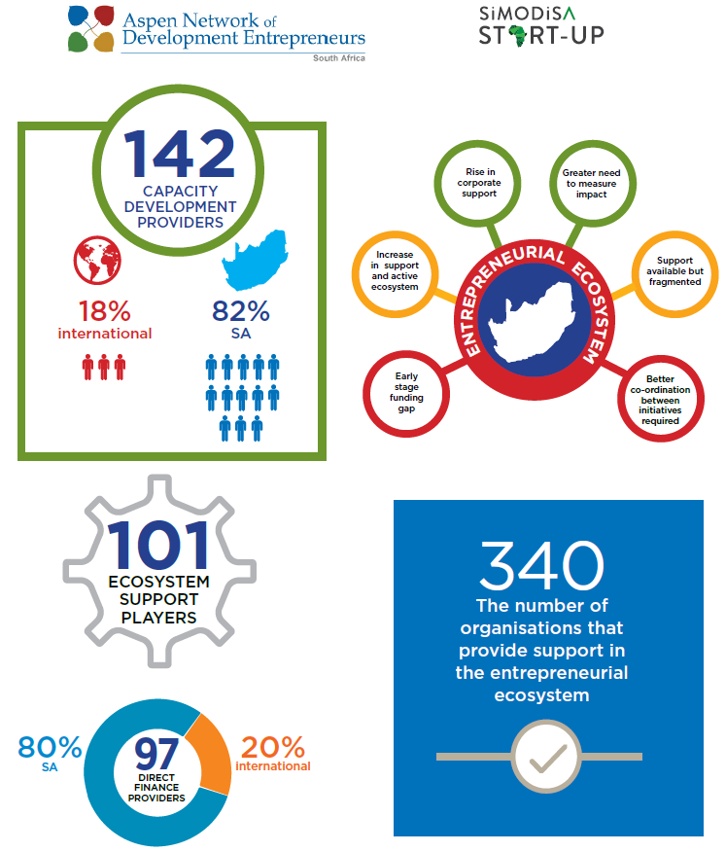 | 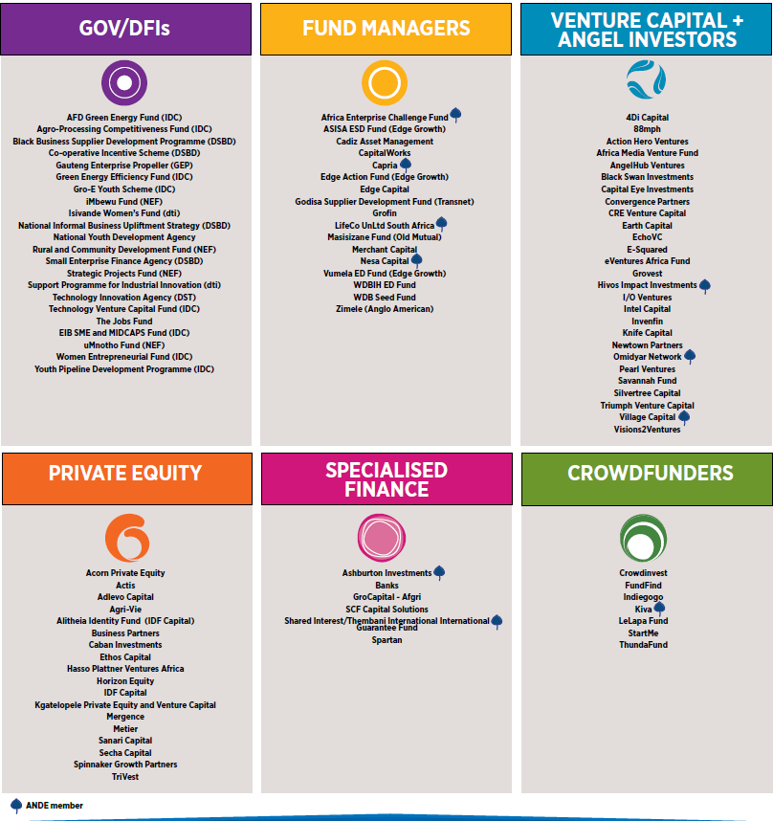
Source: Aspen Network of Development Entrepreneurs (ANDE) South Africa chapter
- With so much support available, it was a surprise to find that South Africa was ranked 58th out of 126 countries on the 2018 Global Innovation Index. This is the same country that is home to a city that is a technological pioneer continent-wide: Cape Town boasts one of the most established technology ecosystems in Africa. With over 20 acceleration programs and 25 co-working spaces, it makes sense that 60% of the country’s technology start-ups are based in Cape Town. However, this also links to the two-tier economy (¶17) and is illustrative of the massive divide that exists in South Africa between, for example, a technology start-up from the vibrant landscape of Cape Town versus a rural start-up from a township in the Eastern Cape Province.
- While the country has many enabling policies and national legislation in place for black, previously disadvantaged entrepreneurs [e.g. Broad-Based Black Economic Empowerment (B-BBEE, 2003); National Development Plan 2030; Vision 2030; Skills Development Levies Act; Employment Equity Act; Preferential Procurement Policy Framework Act], sadly, this support has led to little real change on the ground for struggling entrepreneurs. One in two South African SMEs fails within its first year in business. While many funding options are available to entrepreneurs, financiers are risk-averse and many (including government funders) have very complicated application processes to access funding, including the requirement to provide collateral, which most entrepreneurs, particularly those operating in the informal economy, do not have. Looking at the perceived performance of government entrepreneurship programs (ranked 50 out of 54 by the Global Entrepreneurship Monitor, 2018) and R&D transfer (ranked 52 out of 54), there is still clearly room for improvement (see Figure 2).
Figure 2: State of South Africa’s National Entrepreneurship Support System (2018)
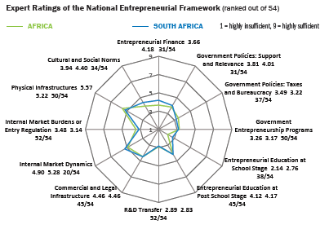 | While the Global Entrepreneurship Monitor’s 2018 assessment of the South African entrepreneurial framework, which was designed to support budding innovators and startups, may look somewhat bleak, within the African continent as a whole, South Africa’s business environment was described by others as “the best in Africa” and a gateway to the rest of Africa for investors (¶108).

- While entrepreneurs have the necessary drive and creative ideas (see Figure 3), they often lack the technological and business skills to break into the market and operative competitively. Furthermore, many coming from the townships are unaware of the opportunities as well as the sectors in which they could meaningfully contribute. They also lack basic resources (e.g. Internet, computer access) to easily move their business to the next level. Furthermore, making sense of the myriad support structures, which operate in a fragmented manner and lack co-ordination, represents a complex and confusing scenario for the average entrepreneur starting out with a new idea or trying to grow a business.
Figure 3: Motivations for Entrepreneurship in South Africa, 2017 Survey
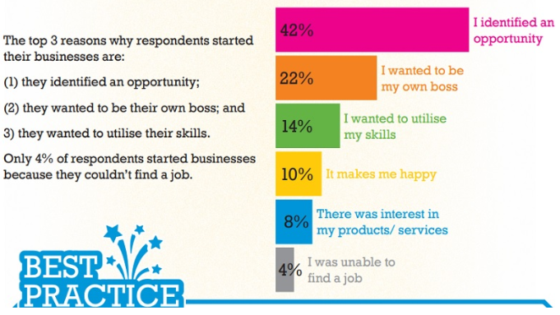
Seed Academy Infographic www.brandsouthafrica.com/investments-immigration/state-of-entrepreneurship-in-south-africa
- According to the Global Entrepreneurship Development Institute’s report, it should be easy to start a business, with South Africa’s good infrastructure network and legislation. However, the country is in 131st place on The World Bank’s list of how easy it is to start a business. Gaining information, meeting requirements, and breaking barriers have proved a real challenge in the double economy. The hope is that technology and innovation build a bridge to overcome the inherent inequalities.
- In her forward to the 2015-2020 Strategic Plan, Minister of Science and Technology Naledi Pandor pointed to the importance of fostering a culture of entrepreneurship and innovation as a key economic driver. She asserted that there has never been a better time in history for South Africans, particularly youth, to develop solutions addressing a range of challenges. While mobile, information and communication technology (ICT) were positioned at the forefront of Industry 4.0 there is rising interest in “green” and “clean” technology to address issues of the “water-energy nexus”, resource scarcity, circular economy, food security, and smart housing. At the time of GCIP’s launch in South Africa, it joined a handful of forerunners (with a regional orientation) in the cleantech incubation space: Climate Innovation Centre (2013) in Gauteng; South African Renewable Energy Business Incubator (SAREBI, 2012) in the Western Cape; Invotech (2012) in KwaZulu-Natal.

Project Summary

Background
- The project traces its origin to the 2011 UN Climate Change Conference of the Parties (COP) in which “Greening the COP17” was launched in South Africa through GEF-UNIDO support, hosted by the National Cleaner Production Centre (NCPC-SA) to: i) establish a platform to promote low carbon technologies in SMEs; ii) increase recognition of the role of such technologies in enhancing SME competitiveness. This first “Cleantech Competition” drew 42 applications covering 3 technology categories (Energy Efficiency, Renewable Energy, Green Buildings), with 23 semi-finalists, 8 finalists, 2 runners-up, and 2 winners. Participating teams from Pretoria, Durban, and Cape Town benefitted from ensuing training on “pitching” and mentorship from (volunteer) South African actors and globally, from Cleantech Open (CTO).
- Building on these results/lessons learned with the aim of accelerating the uptake of clean energy technology innovation in SMEs in South Africa and beyond, GEF and UNIDO collaborated to develop a more comprehensive initiative under the banner of the Global Cleantech Innovation Programme (GCIP). In 2013, country projects were launched in Armenia, India, Malaysia, Pakistan, Turkey, and South Africa. By 2017, Morocco, Thailand, Ukraine joined under subsequent GEF funding cycles. The intention of this “fully subsidised entrepreneurship accelerator program” [was to help] entrepreneurs de-risk their businesses and develop bankable business models and practices, and [facilitate] access to an international network of potential sponsors and partners”.
- At project inception, barriers seen as constraining the uptake of and investment in clean energy technology innovations in emerging and developing countries were identified as follows:
- Lack of an enabling regulatory environment
- Limited access to finance (mismatch of startup needs and offers of government/financing institutions; lack of interaction between SME innovators and potential investors)
- Shortage of entrepreneurial skills (i.e. strategic business planning, communication skills)
- Lack of coordination amongst sectoral players on market intelligence research (undermining decision-making regarding market opportunities and penetration strategies)
- Lack of public awareness regarding low-carbon innovation technology’s market potential

- In September 2013, South Africa’s GEF Operational Focal Point endorsed the project with a GEF grant of USD 1,990,000. USD 6 million in co-financing commitments were made by DTI, TIA, and private sector actors. Table 2 and Section 3.6.2 contain information concerning financial planning.
Table 2: Financing Inputs by Source (planned), 2013-2016
Source of Support | Breakdown by type | Total (USD)
International Donor: GEF | Full cash grant financing | 1,990,000
UNIDO (as GEF Agency) | 70,000 (grant)  70,000 (in-kind) | (140,000)  (included in above)
National Government: The DTI | grant | 1,000,000
National Government: TIA | 320,000 (grant)  4,000,000 (in-kind) | 4,320,000
Industries, other stakeholders, sponsor funds to be mobilized during project implementation | in-kind | 540,000
Total of co-financing sources | - | 6,000,000
Total Project Financing (USD) | - | 7,990,000

- Launched on 21 October 2013 with a 36-month duration (to October 2016), the project aimed to remove the above-mentioned barriers, facilitate development of an enabling “entrepreneurship ecosystem” in South Africa, and encourage SMEs (constituting 90% of formal businesses, providing employment to 60% of the labour force and contributing roughly 35% of GDP) to contribute towards climate change mitigation and adaptation.

Project Objective and Structure
- The project’s objective was to promote clean technology innovations and entrepreneurship for SMEs through an inter-disciplinary approach involving SME clusters, national ministries, provincial governments, academia, industrial associations, financing institutions, foundations, venture capitalists, utilities in South Africa and abroad.
- The project was consequently structured into 3 components, which were underpinned by 6 outputs, led to 3 outcomes, supported by transversal monitoring and evaluation (M&E) activities, elaborated within a results framework (¶63):
- Component 1: Establishment of a Cleantech innovation ecosystem involving a platform to organize the Cleantech competition and associated accelerator program
- Component 2: Strengthening of policy and regulatory framework for the development of a supportive local innovation ecosystem
- Component 3: Institutional capacity building for the organization of the competition and accelerator program

Project Partners and Implementation Arrangements
- As GEF’s implementing agency, UNIDO carried the ultimate responsibility for the project’s timely implementation, working in collaboration with the Technology Innovation Agency (TIA), whose mandate to support the development/commercialization of competitive technology-based products and services, under the supervision of South Africa’s Department on Science and Technology (DST), was seen as an ideal host for pursuing GCIP’s objective (¶31).
- A Project Steering Committee (PSC) was formed with actors deemed to most likely benefit from project outcomes who could play a role in sustaining its results. Under DTI’s chairmanship, with members from UNIDO, DST, Department of Environmental Affairs (DEA), and National Business Initiative (NBI), the PSC was to provide strategic guidance on project implementation, ensure adequate institutional support from participating entities, and review/endorse annual work plans. At the planning stage, Gauteng Province’s Innovation Hub was also identified as a PSC candidate, but the intended collaboration did not materialise at the time due to a very high turnover of relevant staff. Additional stakeholders (i.e. Council for Scientific and Industrial Research-CSIR; National Cleaner Production Centre of South Africa-NCPC-SA; Eskom, relevant Civil Society Organisations-CSOs, universities, the Small Enterprise Development Agency-SEDA, etc.) were expected to contribute in various unspecified ways during implementation.
- A Programme Management Unit (PMU) was established in April 2014 in TIA’s premises, headed by a National Project Coordinator, supported by UNIDO’s Regional Office and staff seconded from TIA. The PMU was responsible for daily management of project activities and M&E, in line with agreed work plans, supervised by the UNIDO Project Manager in Vienna, in collaboration with national partners through the PSC (see Figure 4).
Figure 4: Project Implementation Arrangement
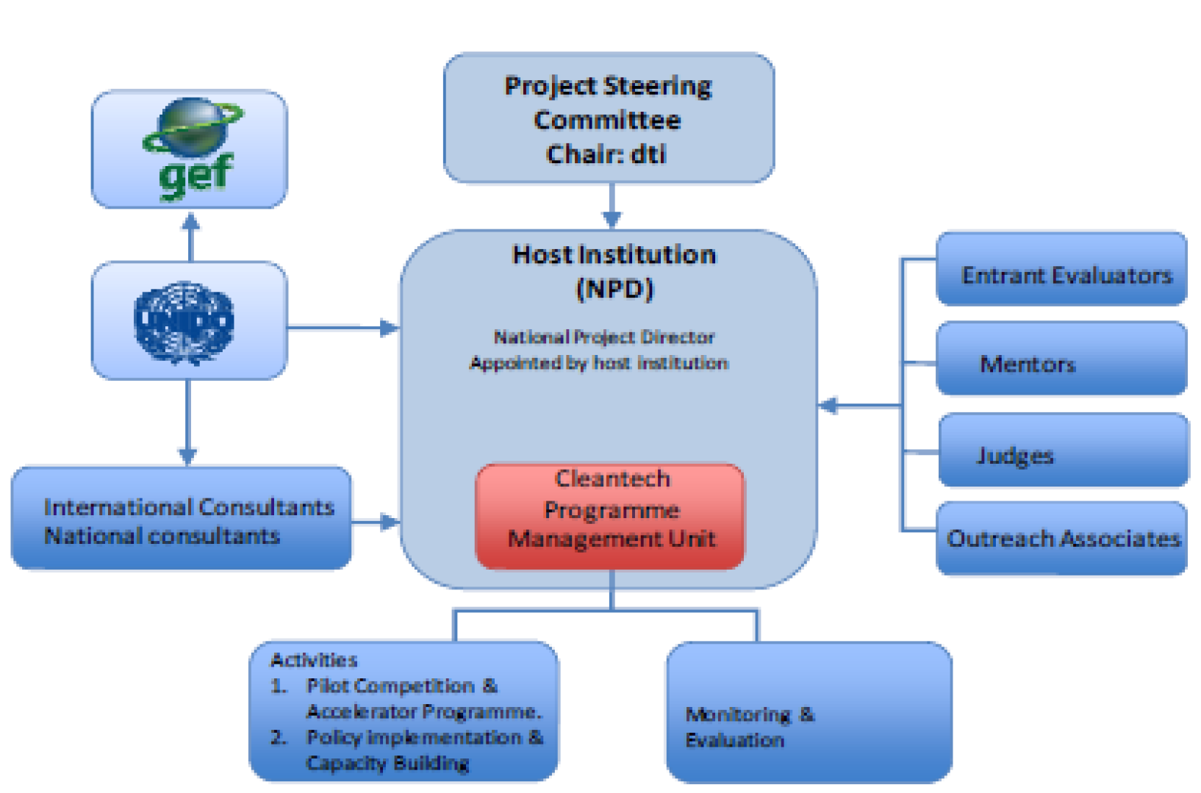

Positioning of the UNIDO Project
- In 2006, UNIDO established a Regional Office in Pretoria, which was responsible for developing, coordinating, and supporting cooperation between UNIDO, the South African government, academia, private sector, and civil society with respect to sustainable industrial development and providing countries of the SADC region (Angola, Botswana, Lesotho, Malawi Namibia, Swaziland, Zambia) with technical support, project assistance, and advice on industrial development issues.
- GCIP was designed to leverage UNIDO’s experience in supporting SME development and to consolidate its learning from implementing the South Africa 2011 Cleantech Competition and various innovative enterprise award schemes (e.g. Innovative and Successful Enterprises in Africa). The project was to be closely aligned with baseline projects and significantly support their ongoing implementation by assisting with the establishment of a supportive innovation ecosystem, supplying existing funding schemes with applicants, and catalysing more efficient investment by improving the disbursement rate and optimizing their funding procedures. These linkages were expected to “allow the national counterparts to gain the necessary capacity to replicate the initiative independently in the future and potentially expand its scope”.
- Synergies were foreseen with other UNIDO activities (e.g. Green Industry Initiative, Eco-Business Partnership Programme in Austria, Green Innovation Expo convened annually in Tokyo by UNIDO’s Investment and Technologies Promotion Office). As the national institution selected to sustain the Competition-Accelerator, TIA was expected to become the connecting node with the Climate Technology Centres Network being established at the time by UNIDO, UN Environment, and others. At international level, the project was to closely coordinate with other similar efforts with the aim of sharing best practices and knowledge that could enhance SME productivity and at the same time, mitigate climate change. Finally, the Project Document envisaged the creation of a network of clean energy entrepreneurs drawn from all participating GCIP countries.

Milestones in Project Design and Implementation
- By April 2014, agreements with the local host (TIA) were finalised, the PMU was established and staffed, and “going live” events were held in 3 key industrial centres (Pretoria, Cape Town, Durban) to build interest and participation in the 1st Call for Applications launched in May 2014. Through a joint decision of UNIDO and TIA, in May 2016, the project was extended a further 14 months, at “no cost”, to 31 December 2017. A further 9-month “no cost” extension was granted until 30 September 2018, to support TIA in the transition, mainstreaming, and sustainability of the project. Table 3 depicts key milestones in the project’s evolution.
Table 3: Milestones and Key Dates in Project Implementation
Background: 2011 Cleantech Pilot Project as part of “Greening of COP17
Launch of and Call for Applications for 2 tracks (adaptive, breakthrough), hosted by NCPC-SA, covering 3 technology categories (Green Buildings, Energy Efficiency, Renewable Energy); 41 applications were received | 15 September - 25 October 2011
International webinar regarding the Competition for all applicants | 1 November 2011
Announcement of Semi-Finalists, ½ day training for Semi-Finalists  through regional sessions convened in Pretoria, Durban, Cape Town | November 2011
Announcement of 9 Finalists; 2-day training on doing 15- and 5-minute pitches | November 2011
Intensive mentorship of Finalists, judging, selection of winners. Involved: 9 volunteer mentors and judges from CSIR, NCPC-SA, partner organisations, CTO | 6 December 2011
Gala Awards event; announcement of 2 winners (1 per innovation track) | 8 December 2011
2013 – Start of Project Under Terminal Evaluation
MSP approval request submitted by GEF to South Africa’s DTI | 8 August resubmitted 21 August 2013
CEO endorsement / approval date | 9 September 2013
Official Project Launch with Technology Innovation Agency (TIA) as the local host | 21 October 2013
2014
Global Cleantech Training Workshop for National Project Managers (Vienna) | 12 – 15 March 2014
Project Management Unit (PMU) established; appointment of National Project Coordinator (Gerswynn Mckuur), Project Assistant, and a project administrator | April 2014
Project Launch regional events (to build awareness ahead of call for applications) | 29 May 2014 - Pretoria  17 June 2014 – Cape Town  18 June 2014 - Durban
1st Cycle: Call for Applications | 29 May – 30 June 2014
First Round judging and announcement of Semi-Finalists | July 2014
National Academy | 24 July 2014
Training sessions in Pretoria, Durban, Cape Town | July 2014
Webinars and mentoring process | August – September 2014
Mock judging | 16 – 17 September 2014
Round 2 judging | 30 September 2014 – Cape Town  1 October 2014 - Durban  2 October 2014 - Pretoria
Gala Awards Event | 16 October 2014
Global Forum (hosted by CTO in California) | 11 – 14 November 2014
2015
2nd Cycle: Call for Applications | 16 March – 15 May 2015
1st Steering Committee Meeting | 26 April 2015
Round 1 judging | 25 – 29 May 2015
Announcement of Semi-Finalists | 5 June 2015
National Academy (during Sustainability Week) | 23 – 24 June 2015
Business Clinic (during NCPC-SA Conference) | 21 June 2015
Mock judging | 28 August 2018
Deadline for submission of worksheets | 16 September 2015
Round 2 judging | 29 – 30 September 2015
Gala Awards Event | 15 October 2015
2nd Steering Committee Meeting | October 2015
Global Forum (hosted by CTO in California) | 16 – 19 November 2015
2016
3rd Cycle Call for Applications | 14 March – 29 April 2016
Announcement of Semi-Finalists | 19 May 2016
Training of mentors and judges | 30 May 2016
1st “no cost” extension of project for a further 14 months, to 31 December 2017 | May 2016
National Academy (during Sustainability Week) | 31 May – 1 June 2016
Business Clinic | 26 – 28 June 2016
Mock judging (during South Africa Innovation Summit) | 21 – 24 September 2016
Deadline for submission of worksheets | 14 September 2016
Round 2 judging | 28 – 30 September 2016
Announcement of Finalists | 5 October 2016
Gala Awards Event | 20 October 2016
3rd Steering Committee Meeting | 26 October 2016
Global Forum (hosted by CTO in California) | 21 – 23 February 2017
2017
3rd Cycle Call for Applications
Announcement of Semi-Finalists
Training for Mentors and Judges | 24 March 2017 (Round 1 Judges)  25 March 2017 (Mentors)  11 September 2017 (Round 2 Judges)
Announcement of Semi-Finalists | 18 May 2017
National Academy (at Sustainability Week) | 13 – 15 June 2017
Accelerator/Business Model training (webinars, mentoring) | June – September 2017
Business Clinics | 17 - 18 July 2017 (Gauteng)  20 - 21 July 2017 (KwaZulu-Natal)  24 - 25 July 2017 (Western Cape)
4th Steering Committee Meeting | 28 August 2017
Mock judging (during South Africa Innovation Summit) | 7 September 2017
Deadline for submission of worksheets | 15 September 2017
Round 2 Judging | Worksheet Review: 2-6 October 2017  Judging (pitches): 9-13 October 2017
Announcement of Finalists | 19 October 2017
Gala Awards Event | 3 November 2017
Discussion of findings & recommendations of Draft Policy Scoping Study on the part of 60 delegates in a workshop convened at the NCPC-SA Conference | November 2017
Global Forum (hosted by CTO in California) | 27 – 31 January 2018
2018
Transition to TIA leadership:  - Running of 2018 program, including piloting of methodology in 2 further sectors where TIA has ongoing activities (Bioprocessing, Medical Devices)  - MoU signed between TIA/UNIDO | March 2017 – January 2019  July 2018
Winding down of UNIDO project, supporting TIA in transition and sustainability | January – September 2018
Terminal Evaluation field mission | 22 May to 1 June 2018
5th Steering Committee Meeting | 29 May 2018
Open Workshop during Sustainability Week with 50 delegates from government, industry, UNIDO, consultants, alumni, mentor networks to discuss Policy findings, fed into Closed Workshop of Project Steering Committee to identify next steps | 6-8 June 2018
Final meeting of Steering Committee (on outcome of Terminal Evaluation) | September/October 2018
National Academy (CTO together with 3 South African trainers-in-training) | 12-14 June 2018
Business Clinics (CTO together with XX South African trainers-in-training) | 16-17 July 2018 (Gauteng)  19.20 July 2018 (KwaZulu-Natal)  23-24 July 2018 (Western Cape)
End of Project under Terminal Evaluation | 30 September 2018
Phase 2 proposal – submission to GEF (7th cycle) | October 2018

Project Assessment

Progress-to-Impact
- At macro-level, the project supports an important cultural shift in post-apartheid South Africa where the majority of the population are being empowered to take their economic destiny into their own hands. Under its business acceleration framework, participants were encouraged to “grow small businesses with great ideas” that meaningfully contribute to solving problems using “clean technology”, create a company, employ others, take risks, and make money. Hosted by TIA, with its academic links and mandate to take university-generated technologies to market, the project had good potential to reach and galvanise young people to embrace entrepreneurship. In this light, the project could be seen as a spearhead in the wider culture change process. According to a PSC member, “in the government’s mind, this initiative is in the right place with TIA. Most of our economy is informal; the level of understanding is not there. This type of project is key to changing mindset”.
- While not an intended effect, the project positively enabled the host institution TIA to significantly strengthen its convenor role (i.e. to organise, coordinate, develop the national ecosystem), enhance its reputation, extend its outreach (¶135), and boost its innovation services (¶98). With the addition of a new transversal category (cleantech) to its verticals, supported by its technology stations (Agriculture, Energy, Advanced Manufacturing, ICT, Natural Resources), TIA was able to tangibly enhance its own system of innovation. As one respondent explained, “TIA takes university technology and tries to get this to market. That’s still their primary mandate. Academic technology looks good; it’s been through the paces, but is typically very expensive to develop, too high quality, and therefore often not commercially viable. Where TIA has been weak is in taking people outside of their comfort zone and pushing them. They can do this through the GCIP as the startups attracted to this program tend to generate more practical ideas which can be commercialised”.
- Before offering any further assessment of progress-to-impact, let’s first recall the project’s overall objective. Formulated in terms of promoting clean energy technology and (SME) entrepreneurship, the indicators/targets specified in the project’s results framework (see Table 4) put the implementing team’s focus on increasing the volume of startups pursuing relevant innovations and ensuring continuation of the supportive mechanism (Competition-Accelerator), which a 2014 Finalist likened to “a mini MBA for green entrepreneurs”. He further asserted, “the GCIP program will radically shift all of the paradigms that you have about your business and will assist you to get the clarity of purpose that you will need to take your idea, concept or business to market and ultimately to commercialization.” Its transformative impact was summed up by a 2015 Finalist who had participated in the cleantech space through other (competitive) programs: “wow, I never knew you could teach an old dog new tricks; it pushed us to develop a business concept in a very practical way and we were continuously challenged to validate it”.
Table 4: Overview of Project's Progress in Meeting its Overall Objective
Project Objective: Promotion of clean energy technology innovations and entrepreneurship in SMEs in South Africa
Indicators | Target | Status as at 30 June 2018
# of SMEs to pursue innovations in clean technologies  Successful cleantech programs organized after project completion | # of clean technologies start-ups/SME increased by 15% | The stated target was not taken up by the project as there was no baseline for this measurement, which was brought to the attention of the GEF in progress reports submitted in 2015 and 2016.  An alternative (and arguably more suitable) indicator can be found in the extent to which the project developed country ownership and its replication ability (¶96).
Additional investment into clean technology innovations due to increased interest in the cleantech program | Investment in clean technology increased by 15% | The baseline for this measurement was expected to be carried out during project implementation. It was not clear if this was carried out or could be with the given resources.  During the project’s 2014 -2017 implementation, 102 startups (i.e. semi-finalist teams) were trained. Furthermore, alumni were provided with local and international opportunities to showcase their ideas, which presumably set the stage for encouraging further investment into cleantech in South Africa.
# of SMEs as members of the national platform (sex-disaggregated data will be collected) | Minimum 450 SMEs participating in the Competition-Accelerator are trained and connected with funding partners and investors | The total number of entrepreneurs who indicated an interest by applying reached 607 over the 4 annual cycles carried out during 2014-2017. Of these, 274 participated in the Competition, funnelled down to 102 who participated in the Accelerator (see Table 9).  These 102 alumni could be considered as members of the national platform, in addition to over 30 trained mentors (many of them also alumni), judges, TIA personnel, private sector topic experts (product development, business model development, intellectual property, funding)
Tons of GHG emissions directly and indirectly avoided | Indirect savings of the project are in range of 815,000 to 1,630,000 tons of CO₂ equivalent | 5 entrepreneurs (of 10 surveyed in March 2017) reported potential GHG emission savings of 181, 897 tCO₂e by 2019. A further 4 entrepreneurs (i.e. 10% of the 40 finalists of 2014-2017 surveyed) reported potential GHG emission savings of 30,159,000 tCO₂e by 2025

- The project’s contribution to conditions leading to long-term transformation was gauged by looking at the extent to which its contributions have been mainstreamed, replicated, and/or upscaled. With respect to mainstreaming: the incorporation of information, lessons learned, and specific results of the project into broader stakeholder mandates/initiatives (e.g. laws, policies, regulations, projects) has not had the time to materialise under the project’s timeframe. Aspects related to strengthening the policy and regulatory environment to favour cleantech adoption were included under Component 2; however, this appears too broadly scoped for the resourcing provided and is beyond the duration of what a 3-year project could hope to put in place. A draft policy scoping study was available (November 2017) and a follow-survey was launched. Their findings and recommendations were discussed in a multi-stakeholder context (June 2018), fed into the PSC, which was currently in the process of identifying next steps, which would presumably set a direction for mainstreaming.
- Looking to replication: from the outset, the project was strongly linked with and housed in the local host’s premises. This setting provided on-the-job training opportunities for TIA staff, which were then put to the test from January 2018 during the transition to full local ownership. The Project Document envisaged that 3 annual cycles would be completed. During 2014-2017, the Competition-Accelerator successfully underwent 4 cycles with the originally allocated resources. Beyond this successful reproduction, 5 South Africans were exposed to the training methodology and 3 of them have been involved in delivering parts of the 2018 National Academy and Business Clinics, together with CTO’s international experts during the 5th cycle (¶102).
- During the transition to full national ownership, TIA launched the afore-mentioned 5th cycle in Spring 2018, exceeding the highest level of registrations reached in earlier cycles (231 versus 221 in 2016). This confirms TIA’s ability to promote and implement the Competition-Accelerator and provides evidence that this aspect has moved beyond a pilot activity, to an operational mode. Furthermore, the lessons learned about what worked and what did not work, as reported during the 5th PSC meeting in which the Evaluation Team participated, have presumably been addressed in the roll out in the design and implementation of the current cycle.
- An unintended effect of initiatives to share experience with other countries (Component 3, Output 3.2) is that applications were initiated (although not completed) from further afield (Kenya, Lesotho in 2017; Nigeria, 2018), presumably flowing through one of the social media platforms or resulting from online coverage. Again, this is an indication of the project’s replication potential.
- Scaling up, in the sense of extending the initiative and results to a larger geographical scale, this was observed through reaching applicants and finalists outside of the principal urban centres where main promotional activities and training were carried out (see Table 5 and Footnote 28). Such outreach has confirmed that the aspiration to go beyond areas with the highest concentration of cleantech startups (e.g. Gauteng, KwaZulu-Natal, Eastern Cape, Western Cape) was realised during the project period, albeit still at comparatively low volumes of participation.
Table 5: Evidence of Scaling Up Across South Africa
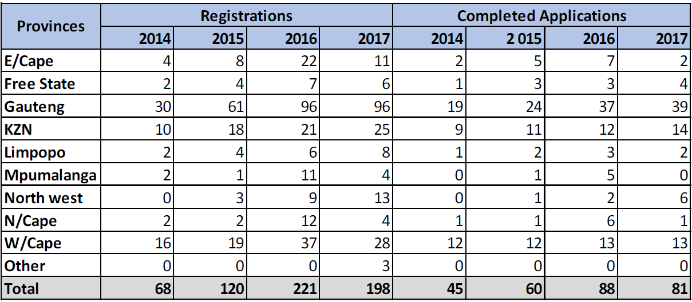
- Scaling up evidence was also found in TIA’s 2018 initiative to add a broad technology category (Environmental Protection: Land, Sea, Air) and extend beyond cleantech to include bioprocessing and medical devices, TIA’s legacy strengths (see Table 12). This evolution demonstrates that the methodology can be extended to other sectors and is considered as a positive achievement.
- Following UNIDO evaluation policy, three further impact dimensions were investigated: safeguarding environment, economic performance, and social inclusiveness. It is confirmed that project activities were expressly designed to advance economic competitiveness by improving the functioning of South African startups, promoting SME entrepreneurship, and stimulating the national innovation ecosystem. In so far that the envisaged platform was expected “to link South African entrepreneurs with investors, business, and commercial partners resulting in the commercialisation of new products, manufacturers, services and ultimately job creation”, it is confirmed that during 2014-2017, the project trained, mentored, and supported 102 startups to advance on their development journey. A variety of stakeholders attested that GCIP alumni were widely seen as having “high quality”, which would, in principle, increase the likelihood for their innovations to reach the market and create jobs.
- In May 2017, the PMU undertook a study of the teams regarded at the time as having the highest potential to succeed, which confirmed that 12 startups were in the market. All held “finalist” positions during their respective annual cycle; however, it was difficult to determine the extent to which their success could be attributed to the GCIP. These 912 startups reported job creation for 2017 in the range of 5 to 120 jobs per startup, for a total of 238 new jobs. Put in the context of the South African government’s vision under its New Growth Path to spur significant job creation by 2020 (¶18), this would seem a miniscule contribution.
- Regarding environmental safeguarding: the project contributed to global environmental benefits by supporting the development of cleantech ideas, solutions, and services on the part of participating startups related to waste beneficiation , energy efficiency, renewable energy, reduction of waste, water efficiency, resource efficiency, green buildings, and more (also see Figure 7).
- Evidence of environmental safeguarding could be found through reduction of GHG emissions. Although participating entrepreneurs were not informed at the outset that the calculation of GHG emission savings would be requested, near project closure, the PMU attempted to gauge the reductions generated by innovations (see Table 6). This initiative is to be applauded in that it focussed entrepreneurs on an important aspect of the project’s long-term impact and provided a first experience for how such calculations might be undertaken and which types of innovations generated which magnitude of reduction. Although the combined estimates of a small portion of the 2014-2017 finalists who responded to the survey substantially exceeded the targeted level in the project’s results framework, these calculations need to be understood in context. The projections were requested for different timeframes (2019 and 2025) and a common methodology was not apparent within or across the technology categories, making linear extrapolations a challenge for the wider group. Furthermore, the entrepreneurs based their projections on perceived sales, but they were not asked to clarify the basis that they used to calculate their projected savings (i.e. kWh avoided or reduced, etc.). Even within this small sample the lion’s share of potential GHG savings was generated by a single respondent.
Table 6: Projected GHG Emission Reductions Generated by Sampling of South African Innovations
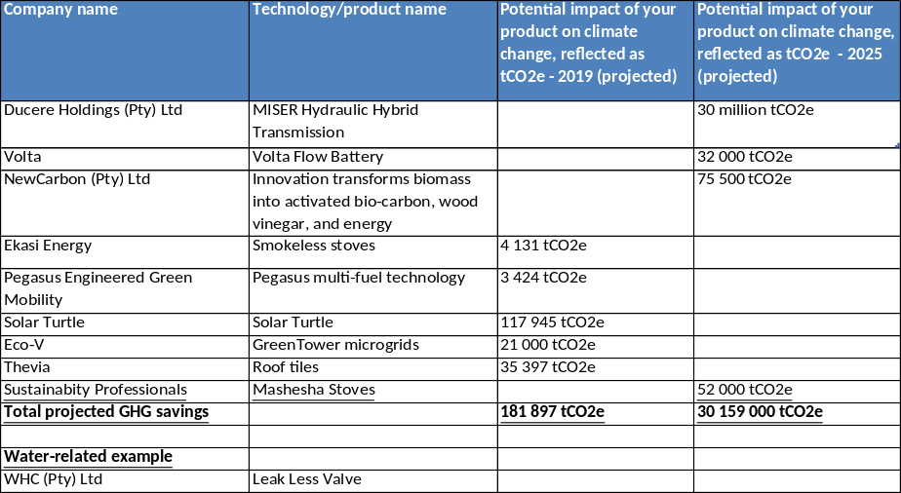
Source: PMU Survey of Most Promising Startups (May 2017)
- Regarding social inclusiveness: the project contributed to women entrepreneurial development and job creation for women by establishing a special category award and setting targets for female participants entering the Competition, participating in networking events, and being trained to organise Competition-Accelerator activities. While the project made slow headway on these targets in the initial stage, further focus was put on gender mainstreaming (see Section 3.4.1), which bore fruit in time. In 2014, none of the finalists were female. By the 4th annual cycle, 36% of the finalist teams (4 out of 11) were led by women. During 2014-2017, women constituted 18.6% of semi-finalists entering the Accelerator (19 out of 102), with almost 29% of the teams (11 of 38) that completed the Accelerator led by women (see Table 9). Of the 231 entries for the 5th cycle launched in 2018, 28% of these (65) were registered by women. Comparative numbers for women-led teams finishing the Accelerator in 2018 were not available at the time of the TE.
- The project broadened its social inclusiveness efforts, beyond Women, to also encompass Youth and Black Entrepreneurs (see Table 7), by using special category awards (Best Women Team, Most Promising Youth Team, Innovation for Social Impact Award), with an award of 20’000 rand per category. The Youth Team winner also received a laptop sponsored by TIA (reflecting its strong youth focus and providing another indicator of the good alignment of TIA as local host). As these categories supported national-level imperatives (¶22), there was significant interest from local media, which is a factor seen to heighten impact through building awareness on the part of potential users of the innovations. Judging from those who won the awards, the use of these special award categories had a positive impact on communities outside the country’s main industrial areas, thereby lending the project further impact. With the handover to TIA and extension to include legacy categories (¶48), a significantly higher proportion (77%) of entries were registered from Black Entrepreneurs (refer to Figure 7).
Table 7: Social Inclusiveness Achievements (2014-2017)
Cohort | 2014 |  | 2015 |  | 2016 |  | 2017
 | # | % | # | % | # | % | # | %
Semi-finalists | 23 |  | 28 |  | 26 |  | 25
Female | 1 | 4% | 4 | 14% | 5 | 19% | 8 | 32%
Black | 5 | 22% | 8 | 29% | 5 | 19% | 8 | 32%
Youth | 6 | 26% | 7 | 25% | 7 | 27% | 10 | 40%

- In sum, the project addressed environmental safeguards, economic performance and social inclusiveness. It also demonstrated the ability for its results to be replicated and upscaled in that the Competition-Accelerator has moved to an operational mode, been extended to further categories (within and beyond cleantech) and outreach to geographies beyond main urban centres has been achieved, although still in a nascent phase. While the methodology has yet to be fully reproduced under local ownership, further efforts to cascade the methodology to local trainers were ongoing at the time of the TE and lessons learned were identified. Overall, the intervention did not yet engage the volume of startups envisaged to benefit from the process and efforts to mainstream the project’s results into broader stakeholder mandates and initiatives needs further time to materialise. This shortfall is balanced by achievements in transferring the project to national ownership and its unintended positive effect in strengthening TIA’s institutional role, which, together, has led to an overall satisfactory rating for progress-to-impact.
The overall rating for progress-to-impact is “satisfactory”

Project Design

Overall Design
- The project clearly identified the problem (climate change) and a means to address this (the business sector and clean energy technology as the main engine and key tool, respectively). In this light, the project was built around the objective of promoting clean energy technology innovations and clean technology entrepreneurship for SMEs across the country. As a large portion of “cleantech” is made up of energy-related technologies, there was a pronounced emphasis on energy; however, the term includes a broader range of sustainable technologies in such areas as water, agriculture, waste, and materials.
- With this objective, terminology, and scope in mind, the project was built on three substantive components, which are seen to constitute an effective approach for evolving a supportive cleantech innovation ecosystem by providing business assistance services to early stage entrepreneurs to support and accelerate these startups towards the commercialization of their innovative ideas, while fostering an environment that facilitates and promotes the adoption of cleantech innovation. Special attention to addressing gender issues was to be undertaken to promote women entrepreneurial development and job creation for women in South Africa.
- M&E activities to ensure effective project implementation were also included and funded following common practice for such a medium-sized project. Regular monitoring exercises were to be conducted, tracking tools were to be developed and used, and PIRs were to be elaborated by the PMU. As well, a mid-term and terminal evaluation were to be carried out. (¶120)
- The implementation arrangements were sound and drew legitimacy from the involvement of relevant partners: i) GEF, which provided grant funding and endorsement used to build awareness/support for the cleantech concept; ii) UNIDO, whose expertise (¶74) was well-recognized, held the role of lead implementing agency; iii) Technology Innovation Agency (TIA) under South Africa’s Department of Science and Technology (DST), as project host, with Department of Trade and Industry (DTI) as PSC chair; and iv) CTO, which, from its Silicon Valley base, provided the platform to handle applications, the methodology and training services of its international experts, and hosted a Global Forum to provide the most promising South African startups (together with those from other GCIP pilots) with further experience and exposure to connect with suitable partners/investors, to bring their innovations towards commercialisation.
- The barriers that the project set out to remove or at least mitigate were laid out in the Project Document and risks were identified at the outset: coordination, incentives, lack of interest on the part of mentors/trainers, and absorptive capacities were all assessed as “low risk” and suitable mitigation measures were identified. On the other hand, “lack of interest by the public and industry” was ranked as a medium risk. Given the potential negative impact on level and quality of participation in the program, a major priority was consequently to be put on adequate resourcing and implementation of communications, outreach through regional workshops, user-friendly entry forms, and online tools, which are seen to constitute an appropriate mitigation strategy.
- The design incorporated the notion that GCIP would take a national coordinating approach, “supplying existing funding schemes with a process methodology and a platform through which they can optimize their funding procedures. Thus, the proposed project will aim to catalyze more efficient investment by improving the disbursement rate of existing baseline projects”, thereby addressing one of the key barriers to the development of the cleantech sector that was identified.
- The project was fully consistent with UNIDO’s mandate to pursue Inclusive and Sustainable Industrial Development (¶74), aligned with national priorities (¶70), ideally suited to its host’s workplan and would moreover function to strengthen and legitimize its convener role (¶41). With these design elements and resourcing in place, the extent of strategic alignment, the constellation of involved actors playing pertinent roles within an approach seen as sound, appropriate, and technically feasible, the overall project design is deemed as highly satisfactory.
The rating for overall design is “highly satisfactory”

Logframe and Reconstructed Theory of Change
- The design for the South Africa project followed the template used by UNIDO for other GCIP pilots. The results framework was logically sequenced and mutually reinforcing. The Competition-Accelerator was to catalyze and mediate project support. This mechanism was expected to dynamize South Africa’s cleantech innovation ecosystem (Outcome 1); develop supportive institutional capacities through “on-the-job” training and set the stage for scaling up cleantech innovation across South Africa, and potentially the wider SADC region in future (Outcome 3); and trigger strengthening of the policy and regulatory framework to facilitate cleantech adoption (Outcome 2) to assure the sustainability of Outcome 1.
- The formulation of outcomes appeared to be little more than a summing up of the respective underpinning outputs. To focus project management on pursuing progress-to-impact and assist the intervention to reach its desired impacts, it is important to articulate outcomes in terms that describe a discernible change in target groups’ short- to medium-term behaviour/performance or system/institutional performance. Table 8 offers some reformulations that encompass behavioural and systemic change, which could be deployed to put attention beyond programmed activities and outputs, to what target groups and other relevant stakeholders are doing with the results and the ways in which they are tangibly benefitting from the project’s support.
Table 8: Examples of Formulations of Outcomes to Support Achievement of Impact
Current Formulation in Project’s Results Framework | Reformulation with Behavioural or System Change
A coordinating mechanism/platform established at the national level of identify, coach and support clean energy technology innovators | The established coordinating mechanism is actively promoting and coordinating clean energy technology innovation and entrepreneurship in South African SMEs
Policies and institutional framework strengthened to promote Cleantech innovations in SMEs and support the local innovation ecosystem | Strengthened policy and institutional frameworks favour the coordination and promotion of cleantech innovation in SMEs and support (dynamize?) the national innovation ecosystem
National institutional capacity built for the mentoring and training program as part of the competition and accelerator program | The Competition-Accelerator has been institutionalized and continues to be regularly organised, supported by capable South African trainers, mentors, and judges

- Indicators for outputs, specific targets, means of verification were mentioned. More attention to their choice, formulation (% increase in absence of a baseline deflected interest in the indicator), and definitions to ensure common understanding and allow for comparison across GCIP pilot countries (e.g. “accredited” and “commercialisation” have been variously understood) would have significantly strengthened the logframe and better guided the implementing team and M&E system. The idea that the project itself would establish a baseline for targets (increase in # of clean technology startups/SME, investment in clean technology) was not realistic with the provided resourcing.
- The Project Document indicated there would be close coordination with other international efforts to share/exchange, links with other UNIDO projects, and the local host would become a connecting node with similar climate technology centres in developing countries (¶38). Together with its national coordination function, (¶37, ¶61), these notions represent important catalytic potential, but they were not referenced in the results framework/indicators and no project activities appeared to provide the scope for creating and leveraging such linkages.
- The policy component of project design needed further investigation and adaptation for the South African context to more effectively guide the project team in an appropriate direction. For instance, the indicator “number of policies and developed to create a conducive policy environment for cleantech implementation” did not reflect the reality that the South African policy and regulatory setting was already very well-developed (¶20) and supportive of green industry and cleantech innovation, with incentives in place to direct specific cleantech subsector innovation. Whereas policy implementation and actual entrepreneurial activity was limited.
The rating for the logframe is “moderately satisfactory”

Figure 5: Reconstructed Theory of Change - GCIP South Africa Project

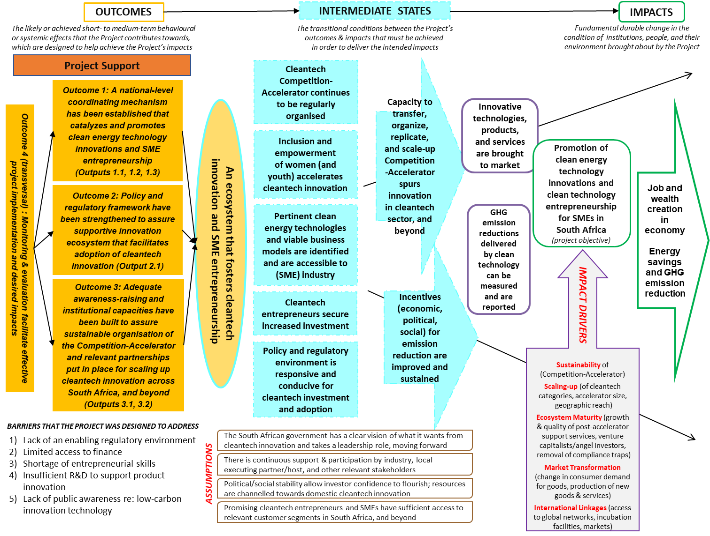

- To deepen understanding of the intervention’s underlying logic, the Evaluation Team reconstructed the project’s Theory of Change (RTOC) with stakeholder feedback. As well as making assumptions and impact drivers explicit, Figure 5 demonstrates how the project could be expected to lead to its results through which causal pathways. Overall, the project’s design has some strong elements; improved formulation and adaptation to the South Africa setting would have made it more powerful.
The overall rating for project design is “satisfactory”

Project Performance

Relevance
- The project’s purpose/objective is fully consistent with global development needs and environmental priorities in promoting commercially viable clean energy technology innovations, which are seen to be a key driver for sustainable socio-economic development. The project was aligned with the 2015 Paris Climate Agreement, 2030 Development Agenda, and Sustainable Development Goals (SDGs), which instantiate the world’s commitment to safeguarding the global commons.
- Respondents across partner agencies confirmed that GCIP supports South Africa’s drive to address global climate change and national issues of job creation, economic development, and environmental protection. Strengthening institutional capacities and promoting a market for clean technology innovations aligned with the national vision to accelerate the transition to a greener economy, which has expanded since 2010, with 32 related policies and strategies currently in place. In identifying and developing capacity of “enablers” to address the “innovation chasm” between research results and socio-economic outcomes, GCIP supported the country’s Ten-Year Plan for Science and Technology (2008-2018). In choosing the local host, GCIP contributed to TIA’s strategic objective, “to provide an enabling environment for technology innovation in collaboration with other role players”. With technology expected to “drive job creation, innovation, and skills into Africa”, the GCIP was ideally suited to fostering the needed mindset and capabilities.
- While the transversal concept of clean technology could stimulate economic growth, cleantech-specific innovation drivers were limited at the time of GCIP’s introduction. A plethora of technology promotion initiatives, innovation competitions, and award schemes aimed at reducing climate change effects were operating in silos. To optimize their disbursement, GCIP was expected to play a national-level coordinating role amongst the custodians of major programs/funds/schemes, who were included within the project’s steering structure or identified as relevant stakeholders (¶34).
- The timeliness of GCIP’s implementation enhanced its strategic relevance. As one respondent explained: “it filled some gaps that came as an externality from the global financial crisis. There were power cuts. Investors were pulling out of developing economies. This created a platform for a new kind of economic thinking, spurred by the impact of COP17 in Durban. There was a gap for entrepreneurship. GCIP empowers people to create their own destiny outside the perimeter of government grants”. In this light, South Africa was seen to have a unique role to play in the wider South African Development Community (SADC), and by extension, within the cleantech domain.
- The Project Document identified the problem to be addressed, offered support to overcome barriers and business assistance to enable beneficiaries to transform their cleantech ideas into viable commercial solutions. Startups interviewed in Pretoria, Cape Town, Durban pointed to the strength of content vis-à-vis validation and for developing business insights under the Accelerator. At the same time, while acknowledging that having CTO as a partner was useful for getting to know what was happening in the cleantech space in the United States, alumni indicated that the GCIP needed to be much more adapted to the South African landscape to maintain its relevance and effectiveness.
- For UNIDO, the project was highly relevant to its mandate to pursue Inclusive and Sustainable Industrial Development. The agency’s 20 years of experience in technical cooperation for industry (especially SMEs) through technology transfer, resource-efficient and low-carbon/energy efficient industrial production, clean energy access for productive use, and capacity building for implementation of multilateral environmental agreements could all be leveraged under the GCIP framework. As one UNIDO respondent furthermore explained, “GCIP offered us an eye-opener for the South African audience. It was a catalytic element to introduce Industry 4.0 to the public and government officials alike through very visible applications and concrete examples”.
- From the donor side, the project was fully aligned with GEF’s focal area priorities (GEF Council’s Revised Strategy for Enhancing Engagement with Private Sector, Modality 3 “SME Competition Pilot: Encouraging Entrepreneurs and Innovators through a Competition/Incubation Pilot”). The intention to include/empower women reflected GEF Policy on Gender Equality.Opportunities were also foreseen to coordinate with GEF Climate Change Focal Area activities in South Africa.
The rating for relevance is “highly satisfactory”

Effectiveness
- The project’s success in addressing its overall objective was reviewed in Section 3.1 as part of gauging progress-to-impact. The assessment of the project’s effectiveness was undertaken at a more granular level by reviewing achievements of its 3 envisaged outcomes, underpinned by their 6 programmed outputs, designed to support the intervention in pursuing its main objective.

Outcome 1: A coordinating mechanism/platform established at national level to promote clean technology innovations and entrepreneurship; clean energy technology innovators identified, coached and supported during and beyond the Cleantech competition
- Outcome 1 was designed to promote South Africa’s entrepreneurship ecosystem by assisting in identification/early stage nurturing of the most promising innovative clean energy technologies and facilitating global networking with mentors and potential business partners abroad. Table 9 provides the status and overall assessment of achievement of each programmed output.
Table 9: Summary of Project's Success in Producing Outputs under Outcome 1
Outcome 1: A coordinating mechanism/platform established at national level to promote clean energy technology innovations and entrepreneurship in SMEs; clean energy technology innovators identified, coached, supported during and beyond the Cleantech competition
Indicators (Target) |  | Assessment and Status as at 30 June 2018
- # of innovative businesses created/accredited |  | 102 cleantech SMEs/start-ups were supported through the Competition-Accelerator program, which was aimed at de-risking them and getting them closer to investment readiness
- # of prizes for innovators with great impact on women entrepreneurial development and job creation |  | 2014 – 2016: Special category award for “Most Promising Female-led Team” given at national gala  2017: Category changed to “Best Female Team” to ensure depth in female participation  Youth participation also supported through a special award, initially “Most Promising Youth-led Team”; changed in 2017 to “Most Promising Youth Team” with the aim of widening participation
Programmed Outputs | Indicators (Target) | Assessment and Status as at 30 June 2018
1.1 Three annual national Cleantech competitions organised | # of entries (100-300 per Competition; 10% women participants)  # of semi-finalists (40-50)  # of finalists (10-15) | Achieved, although less input into the Accelerator each year than targeted by the original design  - During 2014-2017, four annual Competition-Accelerators were organised  - 102 SME/start-ups directly trained and mentored through Accelerator, and supported  - Average number of applicants initiated per year – 152; average number of entries to the Competition per year – 68  - Average number of semi-finalists per year – 25  - Average number of finalists per year - 10  - Women-led teams per year- 22%
1.2 Three associated accelerator programs organized, including post competition support | # of boot camps, training workshops, mentoring sessions organized  Improvement of disbursement rate of existing funding programs | Achieved, although less input into the Accelerator each year than targeted by the original design  22 training workshops organised cumulatively over the 4-year period of 2014-2017 (National Academy, Business Clinics, mentoring workshops to prepare for mock judging, gala event and CTO’s Global Forum, mentor training, judge training, group mentoring sessions for alumni)  Applications were submitted via CTO’s online portal. Incomplete applications were disqualified. Round 1 judging by an external panel of judges took place for all eligible applications, following standard criteria provided by CTO for judging approach/key criteria/standards.  Notes: # of women-led teams indicated in brackets ( )  In view of the importance of support for young and black entrepreneurs in South Africa, participation by these groups was also a strong focus of the program, and was tracked as were female participants (see Table 7)
  Annual Cycle | Total # of applications initiated via CTO platform | Attrition of applications  (due to non-completion or deemed ineligible) | Total # of applications deemed eligible to enter the Competition | Semi-finalists selected (# with female team leader) | Teams that finished Accelerator  (# with female team leader)
  Target |  |  | 100 – 300 entrants per year (10% women) | 40 – 50 per year | 10-15 per year
  2014 | 68 | 34% | 45 | 23 (1, i.e.4%) | 8 (0%)
  2015 | 120 | 50% | 60 | 28 (4, i.e.14%) | 10 (2, i.e. 20%)
  2016 | 221 (52) | 60% | 88 (18) | 26 (5, i.e. 19%) | 9 (5, i.e. 56%)
  2017 | 198 (51) | 59% | 81 (30) | 25 (8, i.e. 32%) | 11 (4, i.e. 36%)
  Total | 607 | 51% | 274 | 102 (19) | 38 (11)
1.3 Participation in regional and global networking activities | # of participants of regional and global networking activities (15) | Over-achieved – an average of 25 participants per year (female-led average per year - 22%) participated in networking activities at regional/global level, exceeding the planned target of 15  Local and international opportunities for showcasing and pitching included: Sustainability Week (industry platform used for National Academy – all semi-finalists); South Africa Innovation Summit (industry platform used for mock judging, industry platform as basis – all semi-finalists), national gala event (all finalists), various industry events in South Africa, CTO’s Global Forum (United States), COP22 (Morocco), Vienna Energy Forum (Austria), Young Enterprise Development Programme (France), Grassroots Innovation Programme (India)

- The project did succeed in establishing the envisaged Competition-Accelerator, which function to promote clean technology innovation and entrepreneurship, running 4 annual cycles during the project period, exceeding its target by 25%. Stakeholders observed that the program focussed to a large extent on the “competition” aspect, mentioned that “a lot of energy was spent on tweaking the Competition to get the right formula. Now they’ve got a really good recipe”, and pointed out “the need to get hundreds and thousands of entrants”. Despite the rapidly-developing entrepreneurship ecosystem (¶20), the team faced a challenge in its early years to build up common understanding on the part of many key actors of the notion of cleantech innovation and business acceleration.
- In comparing the plan for 100-300 entrants to annually reach the Competition, winnowed down to 10-15 finalists by the end of the Accelerator, the project’s performance was lower than expected, despite TIA’s good links with universities and the PMU’s extensive promotion efforts. Shortfalls observed at the earliest phase of the “innovation funnel” (see Figure 6) were related to low volumes of successful entries, with an average of 45% reaching the Competition. Subsequent attrition throughout the process had a cumulative downward impact on the project’s ability to reach its targets. The application process itself was a great barrier to entry. The PMU tried to tackle this problem, offering hands-on assistance during the application process but regrettably “many slipped by the wayside”. As a team member explained, “CTO’s platform took applicants to a US website and the application process was extremely inefficient. People couldn’t understand the questions. In Northern Cape, for instance, many people don’t even have access to a computer. There were many issues with the sign-up process. It took hours to fill out the application. Many people simply gave up.”
Figure 6: Project Performance in Channelling Startups through its Innovation Funnel: 2014-2017
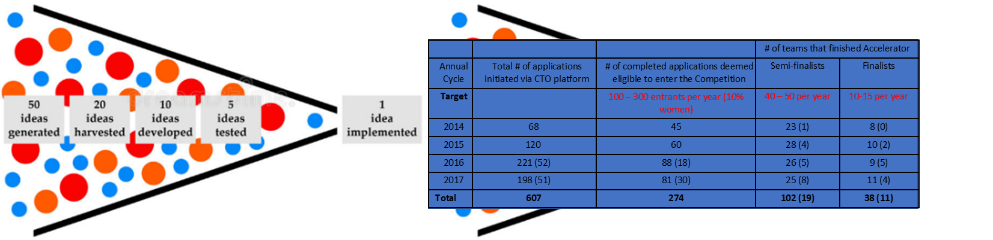
- The notion of an “innovation funnel” is commonly used in the new product development process to visualise the need to start with many ideas, which are examined and whittled down, then shaped into concepts and tested until a final product is selected and launched. Integrating this notion into the GCIP process naturally filtered out many of the entrepreneurs that applied to the Competition. As one respondent indicated, “the winner-take-all process is not suitable. The ones who didn’t make it should not be dismissed as chaff. They should be assigned a mentor or find some other mechanism to help keep them rolling through the process.” The 2016 Competition succeeded in drawing the maximum number of eligible entries (88) but as one alumni recalled “we had a monumental number of drop-outs. You’ve got to be motivated, hand in all of your assignments, have your scenario polished”. On average, 68 entries annually reached the Competition, narrowed down to an average of 25 semi-finalists (versus the 40-50 annual target), narrowed down to an average of 10 finalists, just managing to stay in reach of the 10-15 annual target. The project over-achieved its ambition in providing participants with regional and global networking activities. Endurance and fitting in with the provided framework seemed to be key factors for participating startups to benefit from project support. It was not clear what happened to those that got filtered out or who themselves dropped out of the process along the way, as the project’s M&E system did not follow this up.
- Given the tremendous level of available but fragmented support for startups (¶22), the early stage funding gap, and pressing need for better coordination between initiatives (refer to Figure 1), the selection of TIA as the host institution, with its institutional convenor role and pre-commercialisation mandate, was an asset for the project in playing the national coordination role that was incorporated in the formulation of the outcome. However, the “sensitivity to stepping on others’ mandates”, as highlighted by several actors, seemed to be a constraining factor in pursuing the coordination function, which was presumably linked to the notion of improving the disbursement rate of existing funding programs, although the Project Document did not explicitly spell out how the national coordinating role was expected to be instantiated.

Outcome 2: Policies and institutional framework strengthened to promote cleantech innovations in SMEs and support the local innovation ecosystem
- Outcome 2 was designed to strengthen the policy/regulatory framework to facilitate cleantech adoption, which would assure the sustainability of Outcome 1 and valorise Outcome 3. Table 10 details the status of activities in relation to the specified output.
Table 10: Summary of Project's Success in Producing Outputs under Outcome 2
Outcome 2: Strengthening of policy and regulatory framework for the development of a supportive local innovation ecosystem
Indicators (Target) |  | Status as at 30 June 2018
- Extent to which these policies and regulations are amended or implemented |  | Global Cleantech Innovation Index (GCII) 2017 indicated that South Africa has an extensive cleantech-supportive policy environment and provides incentives directed at specific cleantech subsector innovations, a tangible improvement since the GCII’s 2012 edition.
Output | Indicators (Target) | Status as at 30 June 2018
2.1 Necessary policies and regulations required for Cleantech competition and ecosystem identified and developed | # of new policies and regulations developed to create a conducive policy environment for cleantech implementation  # of policy makers to receive training on policy development | Final draft policy scoping study completed by consultant Nov. 2017. Findings and recommendations of the draft policy scoping study were presented in a workshop at NCPC-SA Conference (November 2017) with over than 60 delegates  Follow-up survey was commissioned to identify common factors with a positive impact on profitability, market penetration, and technology adoption of SME innovations  Findings and recommendations of both surveys were presented during 2 workshops  6 June 2018: Open workshop presented at industry event (Sustainability Week), attended by at least 50 conference delegates from government, industry, UNIDO, consultants, alumni, and mentor networks. Outputs fed into closed workshop on 8 June 2018  8 June 2018: Closed workshop for Project Steering Committee and invited participants to debate findings and recommendations of surveys for consideration as inputs for policy-related White Papers, to discuss possible modes of implementation and steps that could be taken beyond ensuring a supportive policy environment to increase uptake and success of cleantech innovations and entrepreneurs

- South Africa’s policy and regulatory landscape was well-developed, including the cleantech domain. Consequently, there was little need for the project to play a role in creating the necessary policies and regulations in this space. In this light, the PMU was insufficiently guided by the project design (¶67) and embarked on a policy scoping study (in 2017) that seemed to do little more than confirm understanding of the baseline scenario.
- The policy scoping study was launched during the political upheaval of President Zuma’s reign; in hindsight, this may not have been the most effective use of the resources. Due to this component’s limited resourcing, the study was not finalised. A PSC member commented: “if the UNIDO project does its job and brings the lessons as inputs, this is valuable. This is always something that we ask for”. A more useful follow-up survey was commissioned, which focussed on identifying common factors with positive impact on profitability, market penetration, and technology adoption. The discussion of its findings in a multistakeholder workshop (June 2018) that informed subsequent discussion by the PSC is viewed as a tangible step forward, particularly if measures will be identified to increase uptake and success of cleantech innovation and entrepreneurs, given that actual entrepreneurial activity had already been deemed as limited, with many barriers (¶22).

Outcome 3: National institutional capacity built for mentoring and training programs as part of the competition and accelerator program
- Outcome 3 was designed to identify, engage, and build relevant institutional capacities to sustain the Competition-Accelerator. Table 11 provides the status and overall assessment of this achievement.
Table 11: Summary of Project's Success in Producing Outputs under Outcome 3
Outcome 3: National institutional capacity built for mentoring and training programs as part of the competition and accelerator program
Indicators (Target) |  | Assessment and Status as at 30 June 2018
- # of human/financial resources of TIA and other counterparts with built capacity |  | Achieved – see details below
- Wide platform of all stakeholders operationalized |  | Achieved – see details below
Outputs | Indicators (Target) | Status as at 30 June 2018
3.1 Capacity building of host institution (TIA) strengthened and wide platform with all stakeholders of the project established | # of TIA staff trained to be able to organize the competition and the accelerator program  # of partners involved in the platform  # of mentors recruited & trained | Achieved – at least 12 TIA staff (including: support staff; at least 50% women) were involved and capacitated through “on-the-job” training through events, communication, stakeholder relations, and taking the role of mentors/judges  5 South African trainers were identified and engaged in capacity-building activities in 2017-2018, with the aim of enabling them to take over from international experts  32 generalist mentors were recruited, trained and involved, with additional alumni from the preceding year’s Accelerator joining as mentors on an annual basis  Numerous partners were involved in the platform: Innovation Hub (Climate Innovation Centre), CSIR, NCPC-SA, Green Cape, Skeg Product Development, Spoor & Fisher, Water Research Commission, 8 universities, various South African incubators, South Africa Innovation Summit, WWF, Cape Media, Africawide, Alive2Green, South African Alternative Energy Association, SAG-SEED program, Sustainability Week
3.2 Experience shared with other countries | # of regional workshops and training courses organised | Achieved – the project shared its experience within the SADC region:  - Namibia (SADC Centre for Renewable Energy and Energy Efficiency - SACREEEE) conference, 2016)  - Zimbabwe: Mission by UNIDO GCIP Project Manager (Alois Mhlanga) and PMU (Petro de Wet) to key private and public sector organisations and academic institutions under consideration as possible country hosts. Participation in 2017 Conference of Zimbabwe Business Council for Sustainable Development

- The project is judged to have made good efforts to engage TIA staff and others who could perform the important roles of mentors, judges, and local trainers. They were capacitated “on-the-job” and supported by briefing material and training sessions to sustain the Competition-Accelerator. The project’s initiative to identify/use a “judging chair” is seen as a very constructive measure, giving the sensitivities in this domain linked to the competition context and the complexity of the judge role. The strategy of approaching alumni (entrepreneurs/beneficiaries) to subsequently play roles as mentors and trainers was a novel idea, given that the skillset of an entrepreneur/innovator can not be expected to necessarily coincide with the capacities of a trainer, coach, advisor, and mentor.
- While GCIP’s national coordination role was not clearly defined during the project period (¶81), the PMU reported extensive efforts to involve numerous institutions in the platform, supporting the notion of creating a wide platform. Engagements with potential partners/sponsors started by the joint UNIDO/TIA team in 2017 have continued (initially including GrowthPoint, First Rand Bank, Nedbank). In a further positive step, during 2018, collaboration was broadened to include: Small Enterprise Development Agency (SEDA), Industrial Development Corporations, TIA’s Technology Stations, and through them, an expanded network of universities.
- In terms of sharing the project’s experience, missions to neighbouring countries (Namibia, Zimbabwe) were undertaken on an opportunistic basis, which is seen to have established valuable ground for going further in the direction of the initial vision that GCIP’s implementation in South Africa could function as a hub for extension throughout the wider SADC region.
- Balancing the project’s performance across its three envisaged outcomes, a ranking of “satisfactory” has been assigned.
The rating for project effectiveness is “satisfactory”

Efficiency
- The notion of efficiency was integrated into the project concept in that with the relatively small GEF grant provided, “this would act as an effective catalyst to boost more vigorous implementation of larger baseline projects and programs”. Efficiencies were also expected to be generated through GCIP’s coordination with UNIDO centres (e.g. NCPC-SA and the Investment and Technology Promotion Centre and their networks) and with other relevant UNIDO initiatives to benefit from their support and create synergies (¶66). Furthermore, through making links with other GEF projects in South Africa under the Climate Change focal area, this was expected to yield cost savings, create synergies, and avoid overlap. Interviews in the field could confirm efficiencies were gained from interaction with and contributions from UNIDO’s long-time partner, the NCPC-SA, but the extent to which the broader level of planned coordination did, in fact, materialize with the corresponding efficiencies and synergies, is not evident from the project reporting, which was organised primarily in relation to the indicators/targets of the results framework.
- Like the pilot projects in other GCIP implementing countries, at the request of UNIDO and the national counterparts, the South Africa project was granted an extension. Consequently, the planned timeline was exceeded by 23 months, although no further resources were added, which meant that the originally allocated resources (grant funding and co-financing) were stretched over a 59-month period (versus the originally planned period of 36 months).
- The PMU reported that frugal spending allowed the project to run 4 annual cycles of the Competition-Accelerator, rather than the three executions that were planned with the provisioned budget. In synthesizing the comments of a range of respondents, the Evaluation Team had confidence that the PMU developed a culture of seeking “value for money” and made solid efforts to steward and account for the provided resources. A tangible example relates to extra efforts undertaken by the team to identify, apply for, and diligently follow through on the opportunity to get a refund of value-added tax, which was then used to fund unplanned, but highly valuable, part-time human resources support from the UNIDO side until December 2018 during the project’s transition to TIA, assuring the quality of the 5th cycle launched under its auspices in Spring 2018.
- The PMU was fully embedded within the local host’s premises from the outset. This provided efficiencies in terms of access to infrastructure and facilitated “on-the-job” training for TIA staff, which is a vital aspect for assuring the sustainable operation of the Competition-Accelerator in future. Furthermore, the project benefitted from technical assistance provided by staff within UNIDO’s Regional Office in Pretoria who were nearby, highly engaged, and went the extra mile to provide support, which can be attributed to the implementation approach (¶151).
- Using an approach of co-financing from national partners and involving them as PSC members enlarged the pool of available support while also building national ownership. Efficiencies were also gained from the voluntary contributions of mentors, mock judges, formal judges, and local trainers who were involved in vital support roles on the project. This simultaneously functioned as “on-the-job” training and was expected to contribute towards sustaining the project results and benefits.
The rating for project efficiency is “satisfactory”

Sustainability of Results and Benefits
- Awareness of the need to sustain the project’s results was apparent from the outset, with the choice of TIA as the GCIP’s local host, steps taken during implementation to build staff capacities to assure ongoing operation of the Competition-Accelerator (¶86), and the success of TIA taking this under its own auspices from 1 January 2018. The comprehensiveness of the PMU’s argumentation in the form of a “business case” and its presentation to TIA’s Executive Committee, together with three scenarios accompanied by detailed business and operations plans. These are viewed as vital elements that were systematically developed and put in place to assure the continuation of benefits. This is seen as a major achievement and the team is to be congratulated indeed.
- During the 5th PSC meeting (29 May 2018), the National Project Coordinator (who ran the COP17 pilot and guided the current project throughout its implementation) announced his resignation to take up a new professional opportunity. While many stakeholders interviewed expressed concern about this unexpected development during the project’s transition to national ownership and inferred that a gap in performance could be expected, the Evaluation Team observed that TIA’s top leadership heightened its understanding of the project’s significance, stepped up to the challenge, put in place an interim leadership team, and initiated recruitment for the vacancy.
- A 5th cycle of the Competition-Accelerator was launched in Spring 2018, which demonstrates that this aspect has moved from pilot to operational mode. This evolution also provides evidence that the project’s outputs and results have been institutionalised and its national-level ownership has been secured, although the ambition to expand the mechanism to sectors beyond cleantech and corresponding resourcing constraints that consequently emerged during the transition appear to be generating a risk of potential staff burnout. As the project moved under TIA’s umbrella in mid-2018, an ecosystem supporter being equipped to be a local GCIP trainer observed, “one of the first noted events was that the team was halved yet the requirements on the team (to expand the GCIP benefits to other sectors), was trebled. This suggests excitement about the project, yet an inability and incomprehension about what is required to run it well. This makes me doubtful that funding can be secured to ensure the provision of my training skills at my company’s charge out rates”.
- The inclusion of entrepreneurs from two other TIA programs, Medical Devices and Bioprocessing, (see Table 12) instantiates the notion that “the GCIP would be integrated into TIA by continuing to use its programmatic training and established networks as blueprints for the organisation to offer similar sector-focussed initiative, thereby building a repeatable, scalable, and value-adding business model” . This has consequently enabled TIA to boost its own innovation services.
Table 12: Expansion of Competition-Accelerator to Include Additional Sectors (2014 -2018)
Annual Cycle | Total # of applications initiated | Total # of applications deemed eligible to enter the Competition | Semi-finalists selected to enter the Competition  (# with female team leader) | Teams that finished Accelerator (# with female team leader)
2014 | 68 | 45 | 23 (1) | 8 (0)
2015 | 120 | 60 | 28 (4) | 10 (2, i.e. 20%)
2016 | 221 (52) | 88 (18) | 26 (5) | 9 (5, i.e. 56%)
2017 | 198 (51) | 81 (30) | 25 (8) | 11 (4, i.e. 36%)
2018 | 231 (65 women, cleantech only)  Bioprocessing and Medical Devices participants were directly nominated by TIA | 71 (17) Cleantech only  Bioprocessing and Medical Devices participants were directly accepted as semi-finalists | 20 (2) Cleantech only  11 (9) Bioprocessing  14 (6) Medical Devices | Finalists to be announced 22 October 2018 for Cleantech, Bioprocessing, and Medical Devices

- Based on entries to the 5th cycle launched by TIA in Spring 2018, the project’s environmental safeguarding and social inclusiveness impacts are continuing (see Figure 7).
Figure 7: Sustaining Impact in Environmental Safeguarding and Social Inclusiveness (2018)
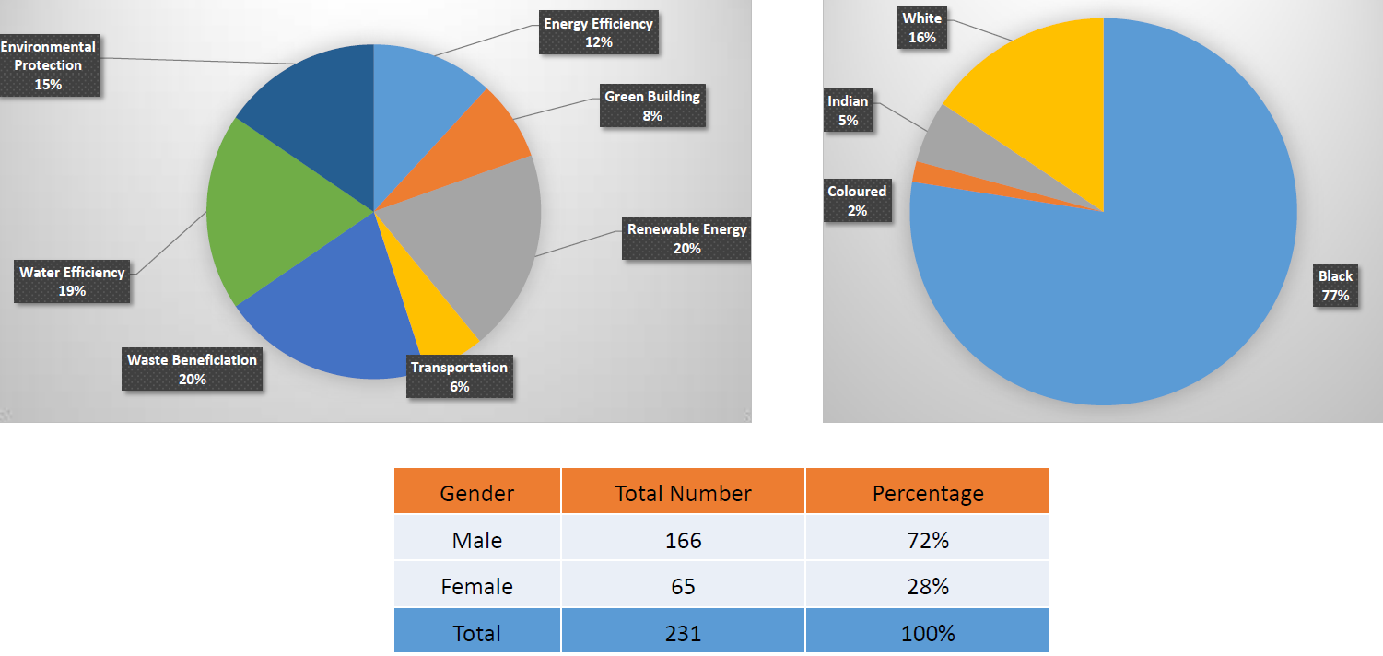

- Beyond having an institutional “home”, sustaining the project’s results is linked to having sufficient, qualified resources on hand. By design, substantial volunteer resources (¶147) are to be leveraged from ecosystem support actors taking the roles of mentors, judges, trainers, advocates, etc. While offering major cost synergies and enlarging the pool of available resources to support the endeavour, this translates into immense administrative and logistics support needs and introduces an element of unreliability in that such actors are not necessarily available and may prioritize other engagements.
- The initiative to build up local training capacity started relatively late in the game to be assured that adequate capabilities would be available following project closure. In this regard, 5 mentors approached by the PMU agreed to take part in a training-of-trainers initiative, which involved a 1-day training session (June 2017); attending mock judging day at the South African Innovation Summit (September 2017) and Gala Award event (November 2017); together with CTO’s international experts, delivering parts of July 2018 National Academy and Business Clinics (i.e. giving feedback on participants’ pitches, handling 1:1 sessions with participants on application of the business model to their ideas); committing to being a GCIP trainer in future, depending on the assessment of their capabilities (by TIA, CTO, UNIDO) according to criteria provided by CTO; and registering with TIA as a service provider to be contracted by TIA from 2019 onwards.
- While the structure was well-designed, finally not all 5 local trainers participated in the training-of-trainer activities designed to consolidate their competences due to scheduling conflicts related to work for which they were being compensated (regular day jobs or consultancy mandates). By July 2018, it appeared that only 1 of the 5 had participated in all elements and this person is an employee of a sister government agency (to what extent does this allow for registration as a service provider?). The arrangement for contracting local trainers was not clear (the extent of work that would be available, under which conditions, etc.) which may prove a detracting factor in future. Participants’ feedback on 3 local trainers who were available to take part in the July 2018 National Academy was positive “in terms of their business knowledge, knowledge of the GCIP Business Model methodology, ability to explain and illustrate concepts, and ability to fully and satisfactorily respond to questions”.
- While communicated in May 2018 to local trainers that they should register as service providers to TIA for contracting from 2019 onwards, thereby positioning TIA to be independent of outside expertise for running the Competition-Accelerator, during the roll-out of the 2018 National Academy/Business Clinics, sentiments were expressed about maintaining participation of CTO international experts for another year. While this recognizes the value of their contributions, this also infers that local capacities can not yet be sufficiently relied upon to deliver the methodology.
- During implementation of the 5th cycle, which was ongoing during the TE, it was becoming apparent that the arrangement put in place would need further time, support, and resourcing to be fully assure the continuation of the project’s results. Following the July 2018 National Academy and Business Clinics, there was positive feedback and recognition of the challenge “the TIA team, supported by UNIDO, have made a huge effort to keep the program going. The logistics required for the 44 teams, mentors, trainers, and experts to meet in 4 different location is immense”, together with a serious concern about what will happen at the end of the year when the UNIDO resources that have supported TIA during the transition taper off.

Financial Risks
- Significant efforts underway to ensure the availability of financial resources following project closure resulted in a decision by TIA’s Executive and Board to approve the GCIP’s incorporation into TIA from 1 January 2018, with an associated budget and human resources allocated based on a Business and Operations Plan for the period 2018–2021. During the 2018 transitional period, UNIDO provided additional support in the form of part-time human resources from the PMU team until December 2018 to assure the handover and contribute on knowledge management aspects.
- The formalisation of the move to national ownership can be interpreted as a positive investment in the cleantech innovation space, aimed at strengthening the sustainability of current and future participants. TIA did state its intent to ensure that alumni benefit from its other funding instruments, national and international networks, which are seen as important levers to reduce financial risk. With a view to diversifying funding sources and strengthening prospects for further securing institutional sustainability, initiatives to pursue corporate partnerships and sponsorship initiated in 2017 has been continued in 2018. Furthermore, a GCIP-SA Phase II proposal was being developed by TIA during the TE. In case funding would be secured under the GEF Cycle 7, such support would significantly reduce the financial risk of the project’s continuation.
- Commercialization is the biggest hurdle facing entrepreneurs. Assessing the likely availability of resources involves gauging the availability and effective channelling of public support, extent of private investors/venture capitalists/angel investors, and their willingness to invest in cleantech innovation. While the project did not fully seize its envisaged national coordination role (¶61), with GCIP moving under the TIA umbrella and “its role as a facilitator, connector and funder in South Africa’s entrepreneurship ecosystem”, there is good reason to believe that this institutional arrangement will facilitate cleantech startups in accessing support and funding to progress on their development journey and reach commercialisation. South Africa’s entrepreneurial ecosystem offers extensive support, much of it from domestic sources, and appears set to rise (refer to Figure 1).
The rating for financial risks is “likely”

Socio-Political Risks
- While largely beyond the control of the project and its implementing partners, socio-political stability allows investor confidence to flourish, which can positively influence the realisation of the project’s intended impacts (see Figure 5). The February 2018 election of President Cyril Ramaphosa, a leader who many believed could restore hope and erase the memories of the Zuma years, seems to have set South Africa on a positive path, improving the country’s socio-political risk profile. While acknowledging ongoing, deeply rooted challenges (¶15, ¶18, ¶22), current assessments of the country’s business risk offer room for optimism: “with the most sophisticated and developed economy in Africa [with] some high class companies in finance, real estate and business services, manufacturing, wholesale and retail trade, South Africa is the ‘gateway to Africa’ for investors due to its comparative sophistication, ease of doing business (compared to African counterparts), continental expertise and ability to act as a base for critical services for doing business on the rest of the continent….the business environment is challenging, but still one of the best in Africa.”.
- South Africa’s government strategy documents stress the importance of sustainable inclusive economic growth and development, which requires balanced regional development (¶18), affirmative action for previously disadvantaged groups (¶22), better functioning SMEs, diversification of energy sources (¶17), and building the capacity of “enablers” (¶70). The project positively contributes on all of these fronts and can therefore be expected to continue to engage the interest and support of the current PSC members, and beyond, moving forward under TIA’s auspices.
The rating for socio-political risks is “likely”

Institutional Framework and Governance Risks
- The decision by TIA’s Executive and Board to incorporate and resource the GCIP within its own structure provides a valuable institutional setting for assuring the sustainability of the project’s results. TIA’s hosting of the GCIP strengthened its ability to carry out its mandate and it has boosted its own system of innovation. A strong sign favouring the project’s sustainability comes from TIA’s supervising ministry and funder, DST, which expressed support for bringing the GCIP under TIA’s wing “the program had many positives. We’ve taken a decision as a country to make it sustainable”.
- The debriefing session that took place with TIA’s management team on 1 June 2018 in relation to the interim findings, sustainability of the project’s results, and its own institutional capacity was insightful and provided a platform for TIA and its new leadership team to share their strategy and commitment, with the GCIP moving forward under their tenure. This session was experienced very positively and conveyed confidence in TIA’s institutional capacity and governance framework.
- During internal planning sessions subsequently convened in TIA during the transitional period, areas that needed further attention and support were regularly identified and brought forward to TIA’s Executive. This indicates that an internal management and governance structure is in place and the incumbent governance structure is still in operation, attested by the GCIP’s PSC next meeting scheduled in Autumn 2018 to discuss the TE’s findings/recommendations. TIA indicated its intention to continue with the PSC, whose role and ToR will be determined during the upcoming meeting.
The rating for institutional framework and government risks is “likely”

Environmental Risks
- The project’s support contributes to global environmental benefits. The cleantech solutions being developed by participating startups reduce environmental risk and are valuable, given the priority of South Africa and the world community on climate change mitigation and adaptation (¶51, ¶69, ¶70).
The rating for environmental risks is “highly likely”

The overall rating for sustainability of results and benefits is “likely”

Assessment of Cross-Cutting Performance Criteria

Gender Mainstreaming
- The UN has a mandate to promote social justice through gender equality. Gender mainstreaming involves necessary temporary gender-specific measures to combat direct and indirect consequences of past discrimination that have left women or men in a particularly disadvantageous position (¶15). Under its Gender Policy Framework, South Africa put gender mainstreaming at the heart of efforts to transform its economy. DST’s 2015-2020 Strategic Plan prioritized the need to address gender (and racial) imbalances in the country’s science and technology workforce (under 40% of scientists, engineers, and technologists are female). With these aspects in mind, the project’s design incorporated elements to contribute to better gender equality and gender-related dimensions (¶57).
- In this light, targets were set for female participation; these were tracked and reported annually (see Table 9). The GCIP-SA project team itself was majority women (4 of 6 staff members). Proactive measures were taken to recruit, train, and retain female mentors (22% women) and judges (45% women). From the outset, annual Calls for Applications were directed at universities and women’s organisations (Association for Women in Science and Engineering; Business Women’s Association of South Africa; Women, Energy and Climate Change Forum; Women for Climate Justice; Women in Mining SA), as well as women-focused initiatives in government departments (e.g. Department of Women, DTI’s Gender and Women Empowerment Unit within its Broadening Participation Division; DoE’s Community Upliftment Directorate). Through its initial years, the project’s achievements on gender mainstreaming could be best characterised as incremental. Progress monitoring showed below-target participation from women and that a more active approach was needed.
- The project’s performance on this dimension improved in 2017 with the addition of expertise made available via UNIDO’s Regional Office through a shared resource attached its Industrial Energy Efficiency project, who provided technical assistance on stakeholder engagement and gender mainstreaming, which coincided with a recognition that more insights were needed about the barriers and reasons for people falling out of the process. Consequently, in 2017, workshops held at 8 universities resulted in applications from 8 women-led teams to that year’s Competition. Women semi-finalists increased to 32% (up from 19% in 2016 and 14% in 2015) and a women-led team (SharkSafe Barrier) was selected as a runner-up, which demonstrated that intensified efforts and a more tailored approach made a difference for assuring women’s access to the project’s support.
- According to the National Centre for Women and Information Technology’s (NCWIT) study, gender-diverse management teams outperform their counterparts in terms of improved innovation, superior team dynamics, and productivity, warranting the project’s affirmative efforts. However, NCWIT’s study also found that organisations benefit most from gender diversity initiatives when they create a supportive infrastructure. Female alumni interviewed for the TE indicted that they experienced tension between the GCIP’s stringent pace and expectations and their cultural and domestic responsibilities. As well, the ruthless approach unveiled in the training to prepare startups for eventual pitching to investors unwittingly appeared to function to maintain the disparity of disadvantaged groups (¶155). A white male respondent, who reported that his participation in the program enabled him to tap into significant funding for further developing his innovation, observed, “the trainer comes from Silicon Valley. He is rude and merciless; he can be like a hammer. It’s daunting. For us serial entrepreneurs with relatively well-developed ideas, it was great. But if you want youth and women in the program, you can’t do it with this approach. The women were terrified. A lot of them came to me with complaints”.
- The project showcased women (and black participants) in its communications platforms (online, media, publications) to increase gender awareness and create positive publicity for the beneficiaries and the intervention itself. Examples of profiling include 2016 Impact for Social Innovation Award (Louise Williamson, Sustainability Professionals) and GCIP-SA alumnus who represented South Africa at the 2018 FINE Festival in India (Sandiswa Qayi, AET Hotspot).
- Given the importance of gender mainstreaming to national/international priorities, the project made a slow start on realising the intended achievement, although well-intentioned. The effectiveness of early efforts to address this dimension, as well as the wider aspects of social inclusiveness, improved over time. Efforts to develop a more strategic approach were underway at the time of this evaluation, and it is hoped that this will be more strongly anchored in future.
The rating for gender mainstreaming is “moderately satisfactory”

M & E System

M & E Design
- M&E was designed in accordance with established UNIDO and GEF policies and procedures with the overall objective of providing visibility of the project’s progress. The project’s activities were to be observed and reviewed against performance and impact indicators outlined in the project’s logical framework. The project’s M&E devices included a project inception report, progress reporting, Project Implementation Reports (PIRs), final project report, reporting to the GEF, together with mid-term and terminal evaluations. These mechanisms were designed to facilitate reflection; promote discussion regarding content, scope, and resourcing; stimulate recalibration where needed; and gauge the project’s progress-to-impact and achievements.

M & E Implementation
- M&E implementation was undertaken by the PMU. Project progress was reviewed in PSC meetings; corrective measures were suggested to streamline implementation. The PMU monitored the project’s interventions and results through internal review meetings and compilation of annual PIRs. Progress was shared with executing partners in annual PSC meetings. Stakeholders participating in the TE noted that they would have enjoyed more regular and detailed project progress reports.
- The monitoring plan tracked, reported on and reviewed the project in relation to the energy savings achieved and GHGs emission reductions generated. It also assessed the socio-economic impacts, including those to gender and community, of the project activities to include wide-scale adoption of innovative technologies, better working environments at SMEs and an increase in income levels and opportunities for entrepreneurs and workers. The National Project Manager was responsible for the continuous monitoring of project activities’ implementation, performance and tracking progress towards milestones. The UNIDO project manager was responsible for tracking overall project milestones and progress towards the attainment of the set project outputs and is also responsible for narrative reporting to the GEF.
- Numerous reporting documents were made available to the Evaluation Team. It is confirmed that the PIRs were prepared in line with the GEF project progress reporting system and were submitted an annual basis for 2014, 2015, 2016, 2017, in line with the GEF project progress reporting system. The PMU included self-ratings (with justifications) in the PIRs and highlighted risks and potential mitigation measures. The Evaluation Team benefited from the provision of documentation linked to envisaged project outputs and outcomes, which greatly facilitated the TE, as well as regular and comprehensive detail on every question put to the PMU in the course of assessing the project performance. This attested to the availability of data in an organised fashion and that insights were generated from this to guide the project team and engage with other relevant stakeholders.
- PSC meetings were expected to function as an M&E device, providing supervision and strategic guidance according to national imperatives and/or market needs. PSC meetings took place annually Minutes for PSC meetings convened on 26 September 2013, 15 January 2015, 4 February 2016 confirmed the regular participation of the expected members in these sessions.
Picture 2: Presentation of Preliminary Findings to Project Steering Committee, 29 May 2018
The PSC members were active in meeting with the Evaluation Team to discuss the sustainability of GCIP in South Africa, demonstrated their understanding  of their role in the governance process, and confirmed the project’s value.  The Evaluation Team presented its preliminary findings during the PSC meeting on 29 May 2018. Through this timely consultation session, valuable feedback was gained that could be incorporated into the project’s terminal assessment. | 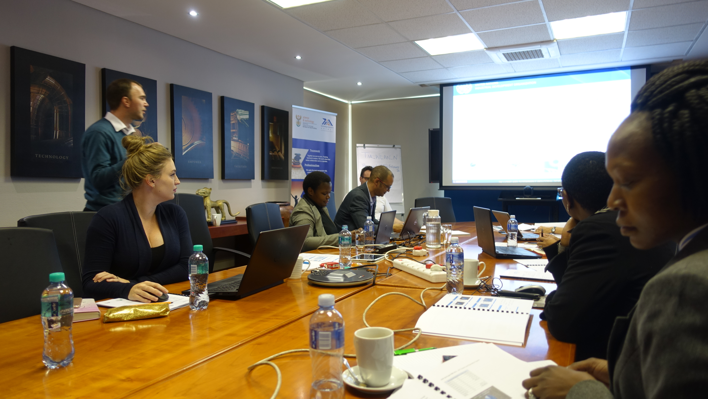
- Both UNIDO’s Regional Office and the headquarters team were regularly engaged in oversight and quality assurance of project and closely monitored the intervention through regular field visits, stakeholder consultations, and progress reporting.
- The PMU is to be commended for its efforts in documenting all project activities, events, trainings, workshops, etc. Overall, these documents were well-structured and presented, and many of these were duly shared with relevant stakeholders. Given the limited M&E resources, efforts to develop and implement M&E mechanisms and collect, analyse, and report data related to project outcomes and impacts indicators were adequate. With higher resources allocated to M&E, this effort could be commensurately enhanced.
- Although a formal mid-term review was not conducted, a member of the PMU reported that “through the PSC and our internal M&E, we did a lot of reflection and going back to the drawing board, looking at how things should be, how CTO fits into the picture”. The project’s terminal evaluation was mandated by UNIDO’s Evaluation Office to independently assess the project’s performance in terms of relevance, effectiveness, efficiency, sustainability and progress to impact and to provide lessons learned and recommendations to inform the development of any next phase of the project and other such future initiatives.

Budgeting and Funding for M&E Activities
- The project budget for M&E activities had clear guidelines and a total allocation of USD 190,000 (i.e. USD 30,000 from the GEF, USD 70,000 from UNIDO and co-financing equivalent of USD 90,000). From the GEF grant, USD 8,000 was reserved for the independent TE. Part of UNIDO’s USD 70,000 contribution of was used by the UNIDO Project Manager and the UNIDO Regional Office in Pretoria (see Table 13).
Table 13: Budgeting and Funding for M&E Activities
M&E Activity Categories | Informing | Timeframe | GEF Budget (USD) | UNIDO (USD) | Co-Financing (in-kind USD) | Responsible Party
Measurement GEF Tracking Tool specific indicators | Project management | Continuous | 10,000 | 30,000 | 50,000 | PMU
Monitoring of impact indicators (per LogFrame) | Project management | Continuous
Periodic Progress Reports | Project Management  PSC Meetings  Annual GEF PIR | semi-annually
Midterm Review/Evaluation | Project Management and PSC | At project mid-term | 5,000 | 15,000 | 20,000 | UNIDO Project Manager, PMU
Independent Terminal Evaluation | Conducted by UNIDO ODG/EVA | At least 1 month prior to project’s end and no later than 6 months after project completion | 15,000 | 25,000 | 20,000 | Independent Evaluator for submission to UNIDO ODG/EVA
Source: GCIP Monitoring & Evaluation Plan, 2013 as per the Project Document
The rating for M & E implementation is “satisfactory”

Results-based Management (RBM)
- After the project’s launch in October 2013, it took 6 months to work out the local host arrangement and establish/staff the PMU (by April 2014). Once this team was in place, the project quickly gained momentum with regional launch events conceived and carried out in three locations ahead of the 1st Call for Applications. This first annual cycle drew 38% more applications (68 versus 42) over the previous pilot for COP17, setting a foundation for broader reach with each subsequent annual cycle.
- The project’s results framework was the basis for developing the annual work plan and PIR structure The M&E system tracked progress on activities, outputs, targets. Attention was paid to recording statistics related to the Competition-Accelerator (e.g. received applications, eligible applications, semi-finalists, female-led teams, mentors, business clinics), as reviewed in Tables 9-11. With this orientation from project design (where outcome formulation was essentially a summing up of underpinning outputs), results appeared to focus more on activities rather than outcomes. Having said that, the team focussed diligently on pursuing those results, hence a rating of “satisfactory” is assigned here and weaknesses in project design was previously noted and assessed accordingly.
The rating for RBM is “satisfactory”

Performance of Partners

UNIDO
- The project’s combination of technical assistance, capacity-building, and policy strengthening reflects current best practice and matches UNIDO’s expertise and experience for this type of intervention. As GEF’s implementing agency, UNIDO held ultimate responsibility for the project’s implementation, contributed the project design, oversaw delivery of planned outputs, and monitored expected outcomes. UNIDO is judged to have carried out its duties in a serious and responsible manner. No instances of financial mismanagement were detected.
- UNIDO’s Regional Office provided ongoing support to TIA throughout implementation and were very much seen to have “gone the extra mile” (¶151). The strategic outlook and hands-on involvement of the Regional Office Head in key moments added vital elements to assuring the project’s visibility and outreach. The supervision and support provided by UNIDO headquarters was highly suitable and added value (¶149). Technical backstopping was conducted by experts identified/engaged by UNIDO.
- The participation and reputation of UNIDO was highly valued by all stakeholders. Many respondents remarked on the importance of UNIDO’s association with the project and expressed strong wishes for its continuation. There was a very high name recognition for UNIDO (with all of its positive association). Respondents frequently referred to the project as “the UNIDO project”, rather than GCIP, which has implications for managing the transition to national ownership.
The rating for UNIDO’s performance is “highly satisfactory”

National Counterparts
- Several government entities took up the invitation of UNIDO to join the GCIP as partners, which also involved becoming members of the PSC, a structure designed to facilitate its national ownership. All those that took part were relevant, able to benefit from project activities and outcomes, and had a key role to play in securing the sustainability of its benefits and results. The PSC structure included government co-financing partners, which allowed them to participate, guide, and measure their investment impact.
- By taking on the lead executing role for the GCIP, and from 2018, absorbing the project under its own structure, TIA strengthened its own role as a bridge for innovation, research and development, broadened its outreach, and enhanced its own services (¶41, ¶98).
- Furthermore, TIA’s parliamentary mandate enabled the agency to engage all relevant stakeholders across national ministries, local and national government departments, science and technology councils, higher education institutes, public entities, and private sector. Fifteen partners participated in the project during 2014-2018; 10 mentors were recruited and trained from various relevant entitles, including: Innovation Hub/Climate Innovation Centre, Southern African Alternative Energy Association (SAAEA), NCPC-SA, Spoor & Fisher, Skeg Product Development, Water Resources Commission (WRC), World Wide Fund for Nature South Africa (WWF), Alive2Green, 1Effect.com and Green Cape.
The rating for National Counterparts’ performance is “highly satisfactory”

Donor
- The GEF Operational Focal Point endorsed the Project Identification Form, triggering a GEF grant of USD 1,990 million. The Evaluation Team confirmed that the timely disbursement of project funds well-supported the envisaged activities and outcomes. Project supervision from the GEF side functioned well. The annual PIRs prepared for the GEF were accepted.
- The GEF’s financial contribution and support through the GCIP for nurturing technology and entrepreneurship was highly appreciated by all stakeholders concerned and perceived to be highly relevant assistance to bridge gaps in resources and capabilities for innovation and acting as a catalytic force for further development of the entrepreneurship ecosystem in South Africa.
The rating for the donor is “highly satisfactory”

Processes affecting achievement of project results

Preparation and readiness / quality at entry
- An aspect that improved readiness and quality at entry is that the current project incorporated lessons from ‘Greening the COP17’ (¶26), setting the ambition (and targets) for the current project according to the experience of this first “Cleantech Competition”. A preparation component was not requested. Explanations for this relate to the project’s (too small) size and uncertainty as to whether the GCIP would be implemented as a program or as individual country projects. The extent to which an updated mapping and analysis of the entrepreneurship ecosystem was carried out at the project’s initiation was not clear to the Evaluation Team. Respondents reported that cleantech innovation was a very new topic for UNIDO and its counterparts and that the project took time to build momentum due to the need to establish common understanding of many of the core aspects.
- The Project Document indicates that one of the key aims was to “create a conducive environment that will allow for the long-term growth of the low-carbon technology innovation sector in South Africa”, but no references were made to emerging frameworks and approaches to assess an entrepreneurship ecosystem that were available at the time. As the financial planning (¶144) attests, the focus was on establishing/sustaining the Competition-Accelerator, which appeared to lose sight of the context in which this mechanism was embedded and the tremendous opportunity to play the national coordinating role that was envisaged as part of the project design. Could a preparation phase have helped to put this more in context and better define and balance efforts?

Financial Planning
- The project was launched with GEF funding, together with in-kind and cash contributions from UNIDO and co-financing partners in South Africa (¶29). The original overall financial plan summary together with its planned breakdown by outcomes, are contained in Annex 4.
- At project start, co-financing partners signed commitment letters totalling USD 6 million (see Annex 4 for details). The planned level of resources and in-kind contributions, which totalled USD 7.9 million were judged to be adequate to implement the project and support its envisaged outcomes. With “no cost” extensions, these resources were actually stretched to cover a 59-month duration. Given that the bulk of other country pilots carried out in the same period also requested and were granted extensions up to 24 months and seeing that this phenomenon also played out in South Africa suggests a weakness in planning (i.e. its original 36-month duration was simply not sufficient for reaching the envisaged outcomes) and efficient spending in utilizing the originally provided resources to cover the significantly longer time span (¶91).
- Analysis suggests that allocations were made based on annual work plans and budgets, which were duly approved by the PSC. Overall, the Evaluation Team has concluded that fund flows were smooth and projected financial resources and inputs were managed and spent in an efficient, transparent, and accountable manner, following UNIDO standard financial management approach.
- In reviewing expenditures (see Table 14), activities related to Outcome 1 (establishment of Competition/Accelerator platform) consumed the lion’s share of total resources (68.4%), followed by the associated Outcome 3 (institutional capacity building to sustain the Competition-Accelerator) at 17.4%, with monitoring/project management at 10% (in line with the standard for a medium-sized project). During the 2014-2017 period, no resources were dedicated to undertaking the mid-term or terminal evaluation., Outcome 2 (policy strengthening) garnered the least resourcing at 4% of the overall budget with activities launched under this rubric primarily from 2016. Year-wise analysis suggests that project expenditures grew steadily since 2014 and were at their highest in 2017. This evolution of spending matches the expected project management cycle. As of July 2018, according to UNIDO’s open data platform, 1,945,396 total expenditures were recorded, representing 98% of the planned budget. The project appeared on track to complete within budget by 30 September 2018.
Table 14: Year-Wise Project Expenditures by Outcome (January 2014 to December 2017)
Outcome | 2014 | 2015 | 2016 | 2017 | Total
Outcome 1 | 372,642.69 | 294,556.90 | 283,289.60 | 358,626.76 | 1,309,106
Outcome2 | 1,121.62 | 0 | 35,239.25 | 40,210.81 | 76,571.68
Outcome 3 | 4,950.83 | 63,647.19 | 130,279.14 | 133,832.50 | 332,709.7
Evaluation | 0 | 0 | 0 | 0 | 0
Monitoring and Project Management | 4,902.40 | 65,349.89 | 57,926.66 | 66,692.42 | 194,871.40
Total | 383,617.63 | 423,553.98 | 506,734.65 | 599,352.49 | 1,913,259.00

Effect of Co-Financing on Project Outcomes and Sustainability
- The project was to be resourced with USD 7.990 million: USD 1.990 million from a GEF grant and USD 6 million co-financing from government actors, UNIDO, industry bodies and others (see Table 15).
Table 15: Co-Financing from South African Partners (planned)
Type | DTI | TIA | Industries, other stakeholders, sponsors, funds to be mobilized during project implementation | UNIDO | Grand Total
In-kind | 1,000,000 | 4,000,000 | 540,000 | 70,000 | 5,610,000
Grant | 0 | 320,000 | 0 | 70,000 | 390,000
Total | 1,000,000 | 4,320,000 | 540,000 | 140,000 | 6,000,000
Source: Project Document

- These co-financing amounts were estimated at the planning stage but were not tracked during implementation. For the specified government co-financers, their in-kind contributions presumably related to staff allocations/secondments, participation in PSC meetings, and other project-related activities. In-kind contributions of other PSC members were not mentioned in the planning.
- Private sector contributions of prizes (worth about USD XXX per annual cycle) and about 160 hours of technical assistance (general session and 1:1 discussions with semi-finalists vis-à-vis intellectual property protection, product development) were estimated to be worth USD 25’000 per annual cycle. Further extensive pro bono contributions were provided by mentors, judges, and local trainers-in-training. These voluntary contributions were not tracked or quantified. Based on data gathered, the Evaluation Team estimated that they were worth on the order of USD XXX per annual cycle.
- While appreciating the significant value of these in-kind contributions for sustaining the operation of the Competition-Accelerator, respondents point out the vital need for the private sector to step up its support and activity within the entrepreneurship space: “big companies that have signed the Paris Agreement, why don’t they come to South Africa and support the most promising startups. Commercialisation is the issue. At the end of the day, someone must buy it. Can’t these big boys invest 0.1% of their effort to not just tell us what to do but to get the economic momentum going?”

Implementation approach
- The implementation approach followed the tried and tested path adopted by UNIDO in all standard GEF-funded projects. The project was managed by headquarters staff in Vienna with oversight and monitoring through regular field visits, participation in PSC meetings, stakeholder consultations, and progress reporting. The supervision and support approach exercised by the Project Manager was well-suited to the PMU’s (high) competency level and engagement, i.e. working through the team, providing a good balance of giving responsibility, avoiding micro-management, while being on hand to support when needed. This style was highly appreciated and effective.
- The PMU established the planning and M&E system and implemented these to assure the project’s smooth and effective functioning, using a results-based management approach (¶130). Workplans and timelines were endorsed by the PSC during its annual meeting. Team members reported that there was very effective coordination between the PMU, National Coordinator, and Project Manager in UNIDO headquarters. The PMU was well resourced and strategically guided, supported and supervised by local dedicated UNIDO staff and the Project Manager in UNIDO headquarters.
- The PMU was housed within the local host, headed by a National Coordinator who benefitted from involvement in the preceding pilot, was extremely well-regarded by stakeholders across the board, who championed the work of the project and regularly recognized team members’ contributions. It was reported that this consistent leadership style created a culture that allowed for “fantastic team work”, open communication, and conflict resolution. In this setting, all team members were highly involved, including providing support as “application mentors” and at times “working fingers to a pulp to pull off some workshops”, which attests to the high level of engagement and hands-on work of the PMU and UNIDO Regional Office joining in this common endeavour.
- Under this implementation arrangement, CTO provided international consulting expertise to organisers and participants in relation to the Competition-Accelerator. Startups, mentors, judges, and local trainers reported that CTO experts showed great interest in South African entrepreneurs and that the content of the training offered by CTO was held in high regard, although its delivery occasionally created unintended effects (¶117). Alumni raised the pressing need for more qualified technical advisors to serve on judging panels and as mentors.
- Regarding knowledge management: the PMU kept good records of activities and could identify and provide all needed documentation to the TE, which is an indication of good achievements in this domain. Furthermore, the project did an excellent job in preparing and publishing an easily-updatable “commemorative book” which provided a consolidated view of the project’s achievements during 2014-2017, including vital showcasing of the most promising innovators that benefitted from project support, which were illustrative of the innovations advanced under the GCIP that contributed to global environmental benefits (¶51). A selection of these are briefly profiled in Footnotes 39-44).
- The Evaluation Team also understood that CTO collected information gathered through the application process and shared this through webinars organized for the PMUs and innovators each year of the GCIP’s operation in the pilot countries. As in other countries, questions were raised in South Africa regarding the storage, use, and access to information collected by CTO, which controlled the application process and the GCIP platform. As one respondent explained, “they’ve mined a massive amount of information from the applications. This information is very valuable. There’s a defensiveness about not wanting to let it go. It’s a value card for them. We should be using it amongst ourselves to facilitate networking”. Many alumni expressed the wish for a platform that would allow for significantly more direct sharing and exchange across the GCIP implementing countries. Such a platform was consistent with the origin vision for the GCIP (¶38, ¶77).

Other Assessments Required for GEF-Funded Projects
- Need for follow-up: the extent to which the project relied on CTO’s platform (obliged by project design) and Silicon Valley approach raises concerns and requires review. GCIP’s implementation in South Africa did not adequately take account of the cultural context: its stringent pace, expectations, and ruthless approach in nurturing startups appeared to unwittingly function to maintain the disparity of disadvantaged groups (¶117).
- Further evidence suggests the platform was inadequately adapted to the context of developing countries/entrepreneurs and filtered out a large portion (55%) of applications (¶79), despite support of “application mentors” from UNIDO’s Regional Office (¶151).
- While there was a move in 2018 to bring other CTO experts on board, during the project’s tenure, on-the-ground training was dependent on virtually a single individual, who has successfully patented the training concept (De Barsey Model) refined under the GCIP framework, with so far insufficient development of local capacity to carry this forward autonomously (¶102), despite having completed 4 annual cycles in most pilot countries. This approach represents a significant risk for sustaining the project’s results and translates into future costs linked to the need to bring in further international experts (¶103), which are no longer gathered together under the CTO institutional umbrella as this organisation evolved its strategy in mid-2018 to focus solely on the United States, moving forward.
- Startups appear vulnerable to potential exploitation by other actors who have privileged information and develop privileged relationships under the GCIP framework. While non-disclosure agreements were prepared and signed, overtures by international trainers (and a few local mentors) were reported, which included discussions about partnering in exchange for equity. The training delivered by CTO did not include any modules on partner qualification that would have equipped the startups to gauge and assess such offers and develop their negotiation skills and position. The Evaluation Team raised this issue with the UNIDO Project Manager and National Coordinator who took it very seriously and indicated that appropriate guidance (Code of Conduct) would be developed.
- Intellectual property (related to the training concept (¶155) and access/ownership issues linked to the data collected through the CTO platform also urgently need to be resolved (¶153). The issues highlighted here are not restricted to the country-level implementation in South Africa; they also point to a higher-level governance issue to be resolved by UNIDO and the GEF.
- Materialization of co-financing: A large portion of support (USD 6 million) involved co-financing to be provided by government partners and private sector actors allowing for broader stakeholder participation, industry sponsorship, and investment in the project’s sustainability. The substantial co-financing amounts estimated at planning stage were not tracked and are assumed to not have materialised to the expected level. The Evaluation Team estimated volunteer contributions provided by private sector actors as being in the range of XXX during the 2014-2017 period (¶147).
- Environmental and social safeguards: This intervention more than adequately incorporated environmental, economic, and social safeguards (¶55; and refer to Figure 7).

Overarching Assessment and Rating Table
The overall rating for project performance is “satisfactory”
- The project was highly pertinent for international/regional/national priorities, addressed target group needs, and it aligned with donor priorities and UNIDO’s mandate. It contributed to global environmental benefits; incorporated economic, environmental, and social safeguards; showed evidence of progress-to-impact; and put in place key institutional elements to secure the transition to national ownership, although further immediate resourcing and additional capacity-building are needed to assure the continuation of benefits. Strengthening of efforts vis-à-vis gender mainstreaming and social inclusiveness bore fruit mid-way. The intervention did not yet engage the volume of startups envisaged to benefit from the process. Efforts to mainstream the project’s results into broader stakeholder mandates and ongoing initiatives will need further time to materialise. Table 16 provides an overall summary of the evaluation findings, justifications, and ratings.
Table 16: Summary of Findings and Ratings by Evaluation Criteria for GCIP South Africa Project
Criterion | Summarized Assessment of the Findings | Section |  | Rating
A. Progress-to-Impact | The project incorporated economic and social safeguards and tangibly contributes to global environmental benefits. A positive unintended effect materialised in enabling the national host to enhance its own innovation services, broaden its outreach, and strengthen its institutional position as a bridge for innovation, research and development. Further evidence of impact was observed in terms of replication and scaling up, albeit nascent. Efforts for gender mainstreaming and social inclusiveness were strengthened mid-way. The intervention did not yet engage the volume of startups envisaged to benefit from the process. Efforts to mainstream the project’s results into broader stakeholder mandates and initiatives need further time to be realised. | 3.1 |  | S
B. Project Design | The overall design incorporates elements that offer coherence; it could be strengthened by improvements in formulation and indicators and inclusion of aspects to create further leverage. | 3.2 |  | S
Overall design | GCIP-SA was based on an existing design used to guide all 9 piloting countries, which the Project Management Unit (PMU) executed according to the 3 pre-defined substantive components, underpinned by continuous monitoring and evaluation to assure its smooth implementation.  The approach was conceptually sound, well-resourced, with a legitimate governance structure. | 3.2.1 |  | HS
Logframe | The Competition-Accelerator served as a backbone to leverage the outcomes. More attention to the choice of indicators/targets and definitions to ensure common understanding and allow for comparison across GCIP pilots would have significantly strengthened the logframe and better guided the implementing team and M&E system. Notions representing important catalytic potential were not explicitly referenced and no project activities appeared to provide the scope for creating and leveraging such linkages. | 3.2.2 |  | MS
C. Project Performance |  | 3.3 |  | -
Relevance | Highly pertinent for international, regional, national priorities, target group needs; consistent with donor priorities and policy; fully suitable for UNIDO’s mandate and competence. | 3.3.1 |  | HS
Effectiveness | The project ran 4 annual cycles of the Competition-Accelerator (above target) although its ability to attract and channel the planned number of startups into this “innovation funnel” was impacted by a maladapted application process, which proved a high barrier to entry, with an average 55% attrition rate. Teams that persevered with innovations at a sufficient level of readiness greatly benefitted from business development and early stage nurturing, which enabled some to tap further resources (although this was not systematically tracked). During the project period, 12 teams were active in the market; the extent to which their commercialisation could be attributed to the project was not easy to gauge. While the GCIP’s envisaged national coordination role was not clearly defined, the PMU undertook to involve numerous institutions, supporting the notion of creating a wide platform. A policy study and follow-up survey were mandated. Findings shared in a multistakeholder context fed PSC discussion to determine next steps. Outreach to share the project experience with neighbouring countries has provided initial ground for extension to the wider SADC region. | 3.3.2 |  | S
Efficiency | Although the originally planned timeframe was exceeded (like most GCIP pilots), the project made adequate use of allocated resources to pursue the envisaged outcomes. | 3.3.3 |  | S
Sustainability of Results and Benefits | The socio-political context in which the project is embedded is evolving positively with the election of a new President in February 2018. The PMU did an excellent job in conceiving and implementing an exit strategy before project closure which has assured that the GCIP’s results have been institutionalised and national ownership has been secured, with an associated budget and human resources allocated based on a Business and Operations Plan for 2018-2021. The project positively contributes on many strategic fronts of top priority to national stakeholders and can therefore be expected to continue to engage the interest and support of the current PSC members, and beyond, moving forward under TIA’s auspices. Further resourcing is urgently needed during the transition period (and likely beyond) to maintain reputation/quality/impact and expand efforts, together with further efforts to develop local GCIP training capacity and assure continued (volunteer?) participation of key ecosystem support actors (mentors, judges). | 3.3.4 |  | L
D. Cross-Cutting Performance Criteria |  |  | 3.4 |  | -
Gender Mainstreaming | Although well-intentioned, the project made a slow start on realising intended achievements; social inclusiveness improved over time, with a more strategic approach underway during the TE | 3.4.1 |  | S
Monitoring and Evaluation (M&E) | UNIDO’s standard M&E approach was designed, adequately resourced, and implemented. The PMU’s monitoring activities were overseen by the PSC, which annually reviewed project progress. UNIDO headquarters effectively oversaw and supported the project, monitoring the intervention through regular visits, stakeholder consultations, and progress reporting. | 3.4.2 |  | S
Results-Based Management | The project teams in Vienna and Pretoria maintained focus on progressing activities, outputs, targets according to the project’s results framework, which drove the M&E system design. Specific attention was paid to recording statistics related to the Competition-Accelerator (i.e. received applications, eligible applications, semi-finalists, female-led team, mentors, business clinics, technology innovations of startups), which overshadowed the focus on outcomes. | 3.4.3 |  | S
E. Performance of Partners |  |  | 3.5 |  | -
UNIDO | UNIDO has undertaken its implementation role and duties in a responsible and highly engaged manner. The agency’s reputation/brand and participation were highly valued by all stakeholders | 3.5.1 |  | HS
National Counterparts | Relevant actors joined as partners and co-financers and became PSC members. As project host, TIA facilitated the transition to national ownership, strengthening its own institutional role. | 3.5.2 |  | HS
Donor | GEF’s contribution through the GCIP to bridge gaps in resources and capabilities for innovation was highly relevant and appreciated. The timely disbursement of project funds very effectively supported envisaged activities and outcomes. | 3.5.3 |  | HS
F. Overall Assessment | The project was highly pertinent for international/regional/national priorities, addressed target group needs, aligned with donor priorities and UNIDO’s mandate. It contributed to global environmental benefits; incorporated economic, environmental, social safeguards; evidenced progress-to-impact; put in place key institutional elements to secure the transition to national ownership, although further immediate resourcing and additional capacity-building are needed to assure the continuation of benefits. Strengthening of efforts vis-à-vis gender mainstreaming and social inclusiveness bore fruit mid-way. The intervention did not yet engage the volume of startups envisaged to benefit from the process. Efforts to mainstream the project’s results into broader stakeholder mandates and ongoing initiatives need further time to materialise. | ¶162 |  | S

Conclusions, Lessons Learned, Recommendations

Conclusions
- Looking at progress-to-impact, the project meaningfully contributed to an ongoing cultural shift where the majority of South Africa’s citizens are being empowered to take their destiny into their own hands. Evidence confirms that the intervention contributed to global environmental benefits (¶51) and contained environmental safeguards [project activities enhanced environmental protection by supporting development of cleantech ideas/solutions/services with GHG emission-reducing potential (¶52]; enhanced economic performance [through boosting the functioning of startups, promoting SME entrepreneurism, stimulating job creation (¶49)]; and sought social inclusiveness [supporting entrepreneurial development of women, youth and black entrepreneurs, and taking steps to reach/engage innovators beyond South Africa’s main industrial centres (¶54)].
- Its replication ability was demonstrated through successful regular operation of the Competition-Accelerator (¶45), which also served to strengthen the local host’s convenor role within the national innovation ecosystem (¶41). Initial scaling up was observed [geographical outreach beyond South Africa’s industrialised regions (¶47), extension of categories for inclusion within (Environmental Protection: Land, Sea, Air) and beyond cleantech, to medical devices and bioprocessing (¶48)] shows promise of the impact that such an initiative could achieve over time, provided that adequate resourcing is available to handle the significant logistics and increased complexity (¶97). While falling short on contribution to long-term transformation by mainstreaming lessons and specific results into broader stakeholder mandates, policies and laws (¶43), it must be recognized that a medium-sized project with a 36-month duration, with an inadequately designed and resourced policy component (¶83) did not realistically have the scope to realise such impacts within its timeframe and budget.
- Project design was based on a template used by UNIDO for all GCIP country projects launched in the same period, with substantive components encapsulating technical assistance, policy strengthening and national capacity building, supported by a governance structure to build national ownership (¶134), underpinned by continuous M&E to assure smooth implementation. This constellation represented best practice at the time (¶131). In the corresponding logframe, notions representing important catalytic potential were not referenced; no project activities appeared to provide scope for creating/leveraging such links. Weaknesses in the results framework were cascaded to the M&E system (¶65) and orientation of its results-based management approach (¶130). More attention to the choice of metrics/indicators/targets and definitions to ensure common understanding and allow comparison across GCIP pilots would have strengthened the logframe and better guided the PMU (¶65). With the focus on engaging, then winnowing down, participation through the Competition-Accelerator (¶79), tracked by # of applicants, semi-finalists, runners-up, and winners – the team lost sight of the GCIP’s envisaged national coordinating role within the larger landscape for which guiding metrics were not mentioned. Without metrics that would have heightened awareness of the need to establish a systematic approach for tracking the path of alumni as well as those who did not progress substantially down the “innovation funnel”, the team missed an opportunity to channel promising alumni and “fallen heroes” to other parts of the ecosystem, who could presumably have provided support to galvanize and continue their journey towards maturity and commercialisation.
- The project was highly relevant for international/regional/national priorities (¶69), target group needs (¶42), and it aligned with UNIDO’s mandate (¶74) and donor priorities (¶75). Its support and nurturing of early-stage startups along a path to maturity and formal establishment leveraging the transversal concept of clean technology was valuable for addressing national priorities for job creation, economic development and environmental protection (¶70). The choice of TIA as local host, with its convenor role vis-à-vis the innovation ecosystem (¶81) meant that the “enablers” whose capacities were developed under the GCIP framework were perceived as having the ability to tangibly bridge the “innovation chasm” between research results and socio-economic outcomes, in full alignment with South Africa’s Ten-Year Plan for Science and Technology (2008-2018).
- In terms of effectiveness, the project succeeded in establishing the Competition-Accelerator which promotes clean technology innovation and entrepreneurship. It built institutional capacity to sustain its operation (¶86) and exceeded its targeted annual runs by 25% (¶78). While its performance in attracting/channelling startups into this “innovation funnel” was much less than planned (¶79), this improved over time with further efforts on gender mainstreaming/social inclusiveness (¶116) and outreach to a broader network of stakeholders who could support dissemination (¶87). Although the GCIP’s national-level coordination role, included in the respective outcome’s formulation, was linked to the notion of improving the disbursement rate of existing funding programs (¶71), the Project Document did not consider the extent of institutional sensitivity to stepping on others’ mandates (¶81) nor explicitly spell out how this coordination was to be instantiated and function in the rapidly-evolving South African entrepreneurship landscape (¶20). The challenge of building up common understanding amongst ecosystem support actors regarding the notion of cleantech innovation and business acceleration, and the immense logistics to manage in relation to the Competition-Accelerator seems to have backgrounded focus on the catalytic role of the project in terms of developing linkages and synergies (¶90). Outreach to share the project experience with neighbouring countries has provided initial ground for extension to the wider SADC region, taking up the notion expressed in the Project Document that South Africa could function as a regional hub (¶88).
- Looking through the lens of efficiency: the project’s timeline was extended at “no cost” (by 23 months), which meant that its resources were successfully stretched to cover a 59-month duration (¶91). As most other country pilots carried out in the same period also requested and were granted similarly major extensions, this points to a weakness in planning (i.e. a 36-month duration was simply not sufficient for reaching all envisaged outcomes) and consequently necessitated frugal spending to remain within the originally provided resources covering a significantly longer time span (¶92) and intensified pressure on staff resources (¶151), who rose to the occasion but to what extent is this sustainable? While the use of co-financing from national partners and in-kind contributions from private sector actors offered cost synergies, the strategy of pursuing voluntary participation (taken up by ecosystem support actors due its perceived value in capacity-building and business development) needs assessment over time to assure the continued viability of this approach (¶100).
- The team is to be congratulated on developing a clear exit strategy and executing it in the project’s timeframe (¶95). The choice and engagement of the “right” institutional host (¶40), involvement of its supervisory Ministry and others in the PSC, backed by co-financing, created a natural path to national ownership, endorsed by the South African government (¶110), vital elements for sustaining project results and benefits. The 5th cycle’s launch demonstrates that the Competition-Accelerator has moved from pilot to operational mode (¶97). The project has positively contributed on many strategic fronts of top priority to national stakeholders and can therefore expect to continue to engage the interest and support of PSC members, moving forward under TIA’s auspices (¶109). Given the expansion and increased complexity taken on during the transition, and considering the vision to use the GCIP framework as a blueprint to offer innovation services to other sectors (¶98), it is vitally important to suitably resource the endeavour (¶97, ¶104) and build adequate national capacities (¶100, ¶102) in order to leverage the reputation, quality, and impact established thus far by the UNIDO-GCIP brand and be able to capably function in an ongoing manner to identify, coach, and support South African innovators in cleantech and beyond and be positioned to pursue the envisaged national-level coordinating (¶71) and catalytic potential (¶138).
- Given the importance of gender mainstreaming to national/international priorities, the project made a slow start on realising the intended achievements (¶115). Although the team was well-intentioned, used a variety of channels and institutional relationships to spread word of the Competition, and diligently tabulated the resulting statistics with respect to engagement of women, youth and black entrepreneurs (see Table 7), the project’s performance on this dimension markedly improved (in 2017) with the recognition that a more interactive approach (university visits, affirmative action) would bear fruit (¶116). The use of special category awards (¶54) and the media profiling subsequently undertaken (¶118) confirms that a strategic approach to advocacy and outreach can tangibly and quickly enhance social inclusiveness. While benefitting from the Silicon Valley approach to business acceleration, the GCIP nonetheless needs to maintain sensitivity to the ways in which some aspects of this approach can unwittingly maintain disparity of disadvantaged groups (¶117).
- UNIDO participation was highly valued by all stakeholders and the agency responsibly carried out its role (¶131). With an implementation approach of being managed by UNIDO staff in Vienna, with planning and M&E carried out by the PMU accommodated within the local host, with technical backstopping conducted by experts identified by UNIDO, the project built important reputation and brand value (¶133). UNIDO headquarters’ Project Manager struck the right balance of supervision and support, which empowered the local team, which generated a high level of engagement and hands-on work of the PMU and UNIDO’s Regional Office in Pretoria joining in a common endeavour.
- Relevant national counterparts were identified and engaged in executing, supervisory, and co-financing roles. While all those that took part were relevant, able to benefit from the project’s activities and outcomes, and had a key role to play in securing the sustainability of its benefits and results, at times, sensitivity about potentially over-stepping one’s institutional mandate may have impeded the PSC’s ability to realise all of the project’s envisaged synergistic potential (¶81).
- GEF’s contribution and timely funds disbursement bridged gaps in resources, capabilities and played a catalytic role through GCIP for further development of South Africa’s innovation ecosystem (¶138).
- In terms of a need for follow-up: the extent to which the project built into the project design dependence on CTO’s platform, providers, and Silicon Valley approach requires review (¶155). While not yet succeeding in building up local capacity to independently carry forward the Competition-Accelerator, inadequate adaption to the cultural context (¶73) led to attrition of applications and unintended effects vis-à-vis social inclusiveness. While responding to wishes for heightened exchange across GCIP countries, data ownership/privacy/access issues need to be addressed and resolved, moving forward.

Lessons Learned
- In the spirit of promoting organisational learning, key lessons have been distilled from the project’s experience to inform UNIDO, GEF and other partners about elements to consider in the design and roll-out of such an initiative to further countries and sectors, and other projects in general.
Lesson #1: Engaging the “right” institutional host is key to a natural path and transition to full national ownership, best executed before project closure to boost sustainability of project results and benefits.
- With a parliamentary mandate to organise/coordinate/develop the national ecosystem, TIA was widely perceived by government actors as ideally placed to host the GCIP (¶40), with relevant stakeholders brought onto the PSC who could thereby support the host and the project through supervision, strategic guidance, and co-financing (¶134) and benefit from synergistic effects with respect to their own mandates. By developing a clear exit strategy and executing this before closure (¶169), the host agency had the opportunity to develop a vision, structure, and 3-year Business and Operations Plan for absorbing the project under its own auspices, refine this with feedback from relevant parties and benefit from external feedback from the Evaluation Team
- During the transition to national ownership, the PMU, UNIDO, and other PSC members were able to observe and step in to support the transition process (¶104), test the project’s replication ability in expanding to additional sectors within and beyond cleantech (¶98), identify emergent opportunities and challenges (¶100), and rethink resourcing needs (¶164) and approaches (¶168) accordingly.
Lesson #2: There is a limited extent to which a medium-sized project with confined budget and timeline can carry out too broadly-scoped policy strengthening ambitions and mainstream lessons and results.
- All GCIP pilots approved in the 2013 period were launched with a GEF grant of under USD 2 million and a 36-month duration. Most requested and were granted a “no cost” extension, including South Africa of 23 months (¶168). Facing a challenge in the early years to build up common understanding of cleantech innovation and business acceleration on the part of many key ecosystem actors (¶78), the PMU team did its best to cope with an insufficiently prepared, poorly-scoped Policy Component set with a too high and too broad policy strengthening ambition, which poorly-oriented outputs and outcomes in this domain, generating missteps (¶83).
- With a more clearly articulated notion of the GCIP’s foreseen national coordinating role and potential to meaningfully stimulate the entrepreneurship ecosystem through leveraging the transversal power of the clean technology concept (¶71), could relevant government actors have been more effectively informed, encouraged, and empowered to overcome sensitivity to overstepping mandates in order to pursue more cross-departmental cooperation to realise gains that feed their own strategic objectives, thereby realising the envisaged synergistic and catalytic role of such an intervention?
Lesson #3: Stimulating and supporting innovation through business acceleration can be expanded to further sectors, therein fostering an entrepreneurial mindset seen as key to unleashing creativity, seeing new ways of doing things, and meaningfully contributing to solving challenges and generating opportunities that enhance environmental protection, economic competitiveness, and job creation.
- The project demonstrated its replication ability in moving the Competition-Accelerator from pilot to operational mode (¶169). Under full national ownership, this mechanism was successfully expanded to include further categories within cleantech as well as entrepreneurs from two other TIA programs: medical devices, bioprocessing (¶164).
- This pilot attests to the feasibility of scaling up and the added impacts that such an approach could deliver in being introduced into sectors and initiatives where entrepreneurism and innovation could be leveraged in pursuing long-term transformational impacts.
Lesson #4: Project design informed by updated insights about the context in which an intervention is embedded and attention in the corresponding results framework to the choice and formulation of outcomes/targets/indicators are vital to drive towards impact, orient the M&E system, effectively guide the implementing team, and serve as a useful baseline reference for project evaluation at closure.
- GCIP’s implementation in South Africa was based on a template with little variation across the pilot country set (¶165). While generic barriers to the development of cleantech innovation and entrepreneurship and the GCIP’s role in removing/mitigating these was documented (¶28), the absence of a preparation phase and its accompanying insights that would have allowed for suitable scoping and tailoring, left the PMU with pursuing three generalised substantive components (¶32). With tailoring to the South African context (¶73), resources invested under the Policy Component could have generated more effective outcomes (¶84, ¶164).
- Metrics very usefully serve to focus the team on achieving the envisaged impacts. Their omission or poor choice can divert team resources or cause missed opportunities to reach impact (¶165). The metrics that were chosen and provided as part of the project design template were relatively easy to quantify and tabulate; however, these, together with Outcome formulations summed up the outputs, but these did not sufficiently orient the team towards tracking and enriching what the target groups and other relevant stakeholders were subsequently doing with their project-generated results and benefits (¶64). Furthermore, the lack of definitions to ensure common understanding (e.g. “accredited”, “commercialisation”) and varying interpretation of provided criteria (e.g. filtering at entry to Competition) did not allow for comparison of performance across the GCIP pilots (¶65).

Recommendations
- The Evaluation Team would also like to offer some recommendations to support the project’s current transition to full national ownership, which may be relevant for other initiatives at the same stage.
Recommendation #1: Ensure adequate resourcing is in place in the short-term to cope with increased complexity; maintain reputation, quality, and impact; and avoid potential staff burnout and attrition.
- With the transition to national ownership, the full-time support of the PMU and UNIDO Regional Office has been reduced. While additional unplanned support could be leveraged from UNIDO (¶104), this is temporary and not sufficient to handle the substantially increased workload (¶104) while also assure the handover and knowledge management aspects, and avoid overloading staff (¶97). The current set-up is not sustainable. While a 3-year Business and Operations Plan was developed (¶105), the envisaged resourcing did not take sufficient account of the effects of the reduced team, emergent challenges during the transition [(including an unplanned recruitment phase (¶96)], and increased complexity of intake due to scaling up to include further sectors (¶48).
Recommendation #2: Review the strategy of pursuing voluntary participation of key ecosystem support actors to assure the endeavour’s quality, reliability, and adequate development of local training capacity to independently carry out the Competition-Accelerator in future.
- The approach of asking mentors, judges, trainers-in-training, and local technical partners to participate on a pro bono basis is a common practice in the world of business acceleration. This strategy offers significant cost efficiencies (¶100) and can function satisfactorily, provided there is an abundance (related to ensuring contingency, and as well because demand often over-strips supply) of accessible, competent, relevant ecosystem actors willing to offer their support on such a basis, commonly linked to a perceived value of corresponding capacity-building and business development opportunities flowing from their participation. In a landscape where the GCIP would be introduced to achieve catalytic effects, typically there will be a need to develop the capacities of those ecosystem support actors as part of the intervention [this argumentation underpins the need for the project’s Component 3 (¶85)].
- As seen in the South Africa case, reliance on volunteer participation has introduced a degree of unreliability in that individuals who have freely participated as mentors, judges, and trainers are not necessarily available for each annual run and may prioritize other engagements (¶102). The reliance on volunteers has also heightened the administrative burden related to regularly securing and renewing participation with each annual cycle (¶104). Alumni also raised the pressing need for more qualified technical advisors to serve on judging panels and as mentors (¶152), which has implications for relying on a purely volunteer system. An initiative undertaken by the PMU in June 2018, following the Evaluation Team’s discussions with IQ Business in Johannesburg to leverage the 900-strong South African alumni network of the International Institute of Management (IMD, Switzerland), headed by IQ Business’ CEO, as volunteer mentors (5 are currently engaged in the 5th annual cycle). This experience should be investigated for its potential to increase private sector support, where transaction costs could be reduced by tapping into established academic, alumni, and corporate networks, which may also have their own interests and emerging business models for offering members valuable opportunities to “give back to the community” or, as CTO frames it, to “pay it forward” (see Footnote ), which would need to be understood to effectively leverage.
- In this light, there is also an opportunity for TIA to adopt a proactive approach in linking to existing “learning networks” across South Africa where the business acceleration approach of the GCIP would be an ideal instrument for network supporters/operators to offer services (to network members), develop their entrepreneurial mindset and culture, and generate solutions to meaningful problems encountered by network members that would enhance environmental protection, economic competitiveness, and job creation.
- The volunteer participation of local trainers-in-training, while individually strongly-motivated, did not yet succeed in them reaching the needed capacitation to independently deliver the needed elements and process (¶103) due to having other commitments during crucial opportunities for consolidation in 2018 (¶102). The hypothesis that these trainers-in-training (and mentors, judges, and other actors) would need to be paid to assure their participation needs further exploration as does the need for alternative contracting arrangements for local trainers, depending on their own organisational setting vis-à-vis the proposal to register as service providers to TIA (¶102)].
Recommendation #3: Strengthen efforts in gender mainstreaming and social inclusiveness, which support national priorities and have been observed to increase the intervention’s desired impacts.
- In view of South Africa’s priority on gender mainstreaming and social inclusiveness, which have been put at the heart of efforts to transform the economy (¶114), and in light of UNIDO’s mandate to pursue Inclusive and Sustainable Development (¶74), further efforts on this important dimension are surely warranted. The project’s experience in undertaking a more interactive approach and affirmative action had the direct effect of delivering more women, youth, and black entrepreneurs into the program (¶116) and markedly higher achievements in making it through the “innovation funnel”, with promising cleantech innovations (see Table 7), often also with important social impacts (see Footnotes 22-28). Engaging previously disadvantaged groups in entrepreneurial endeavour is gaining recognition as an untapped source of innovation. Enabling these beneficiaries to gain the benefits of business acceleration requires a serious investment in advocacy and outreach; such an investment has proven extremely fruitful in other GCIP implementing countries (i.e. Pakistan).
Recommendation #4: Leveraging TIA’s convenor role within the national ecosystem: clarify and undertake the national coordinating role envisaged by the GCIP framework to dynamize/engage other ecosystem actors in supporting alumni and “fallen heroes” on their respective development journeys.
- The Competition-Accelerator at the GCIP’s heart is most relevant for startups at proof-of-concept up to the pre-commercialisation stage, ideally with protectable Intellectual Property where introducing them to a business model and ruthlessly preparing them to pitch to investors would enable them to move up a major notch in their development and commercialisation potential. With the UNIDO-GCIP-TIA branding and outreach through dissemination partners and regional activities, the initiative excited and drew entrepreneurs from across the country (¶47). Naturally, they were at different levels of development, in terms of their teams and innovations. Yet the Competition-Accelerator offered the same experience to all (albeit, an approach that provided cost efficiencies). The 55% attrition rate that arose between applications initiated and those deemed eligible to enter the Competition (¶79) shows untapped interest. The obligatory narrowing down of participants reaching the Accelerator (¶80) represents lost potential which, if channelled to other relevant parts of the ecosystem, could arguably be encouraged to continue on their journey, fostering the development of entrepreneurial mindsets and skillsets that have been identified as key to culture change and economic growth in South Africa, and beyond (¶40). Similarly, once graduated from the Competition-Accelerator, alumni continue to need support, which TIA, through its other funding instruments and networks with other ecosystem actors can presumably provide (¶106). TIA has a great opportunity to undertake this role, which would add significant value to the GCIP concept itself and dynamize the national ecosystem, potentially in the way that its designers intended (¶81).
- In deepening a national coordinating role and efforts linked to strengthening the entrepreneurship ecosystem, it is vitally important to accompany this with suitable metrics that can be used to track and gauge impact, feed into the M&E system, and provide a solid basis for decision-making.
- Moving forward, it is recommended that TIA uses an assessment tool to classify startups at the application stage and channel at this step (many frameworks have been developed and are open-source, which could be adapted to the South African context). Ideally, this would be complemented with a self-diagnostic tool (echoing its assessment methodology) so that start-ups entering the GCIP process can realistically gauge their own level of maturity, see the development path on which they can embark, and maintain “ownership” of their own development. Such a framework could also be used throughout the development journey of the startups, feed into the M&E system, and provide inspiration for suitable metrics to track and gauge impact.

Annex 1. Evaluation ToR
Insert hyperlink – available online

Annex 2. List of Documents Reviewed
Project Documents and Other Relevant Documentation provided by the PMU
GCIP-SA Project Document
PROJECT DOCUMENT_GEF 5 UNIDO CEO End CCM1_Clean Tech South Africa – 21 August 2013
Project Timelines:
2015 GCIP Programme Timeline
2015 Timeline – Activity Breakdown
2015 Draft GCIP Timeline
2016 GCIP-SA Programme Timeline
2016 Programme Timeline
2017 GCIP-SA Programme Timeline
2018 Project Schedule Detailed
2018 Timelines – High Level GCIP-SA
Reports
May 2017, the PMU undertook a study Invitations to participate were sent to all semi-finalists, but
only a small number (usually the same people) responded. Survey input was complemented by anecdotal evidence gathered through the PMU’s contact with alumni and information that they provided in relation to tapping funding opportunities associated with UNIDO, i.e. Private Financing Advisory Network (PFAN), a multilateral public private partnership initiative by UNIDO and the Climate Technology Initiative, and UNIDO’s joint initiative with Korea Technology Finance Corporation (KOTEC)
Media
GCIP-SA Advertisements and advertorials
GCIP-SA Communication reports
GCIP-SA Digital media
Press releases and media coverage
GCIP-SA Media Reports 2015-2017
Communication Oct 2015-Aug 2016
Sasol Solar Challenge Facebook, media exposure
GCIP-SA Gala event media coverage
20140928 Sunday Times GCIP-SA
Marketing collateral
GCIP South Africa brochure produced by the project highlighting its achievements during 2014-2017
Banners
Brochures
Commemorative book 2014-2017
Events
2014- Cleantech Invite
GCIP Invite CPT
GCIP Invite KZN
Go-live CPT
Go-live Durban
Gala Event 2015 Minister Pandor
2016 Gala event
2016 Stakeholder Breakfast event
GCIP-SA 2016 Business Development Events
2017 Gala Event
2017 University workshops
2017 Information Session and Call for applications
2017 Innovation Summit GCIP-SA
Global Entrepreneurship Congress
NCPC-SA Conference Sept 20
Pitch@Palace Andre Nel 20 March
SAEEC 2017 Newsletter info on GCIP-SA
SAEEC Conference A4 e-brochure
VEF 2017 Article for TIA Newsletter
VEF Progam 2017 WEB
Photos and videos
2011 photos and videos
2014 Finalists videos
2014 photos and videos
2014 Global Forum
2014 Launch Event
2015 photos and videos
2016 photos and videos
Sasol Solar Challenge 2016
CTO Global Forum Feb 2017
2017 photos and videos
ENCA Gerswynn Interview
ENCATV news clip.mp4
E-newsletters (12 Oct 2016, 28 Oct 2016, Aug 2016, Dec 2016, Dec 2017, June 2016, June 2017, May 2018)
Women’s Day email Aug 2016
Selected GCIP Stakeholder presentations
Participants 2014-2017
2011 Finalist Summaries
2014 GCIP-SA Potential Impacts
GCIP-SA finalists profile 30Oct2014
GCIP-SA Finalists and Awards Recipients
2014 GCIP-SA Semifinalist profiles
GCIP-SA Participants WWF
GCIP-SA 2014 Participation
GCIP-SA Projects – Water Sector
2014 GCIP-SA winner and runner up
2014 GCIP-SA winners
2014 GCIP -SA winners profile
2015 GCIP-SA Finalists
2015-GCIP -SA Winners
2015 Special Awards Recipients
2015 GCIP-SA Team Profile Finalists
2016 GCIP-SA Finalists
2016 finalist profiles for media
2016 GCIP-SA Semi-finalists
2016 winners
2017 Business Clinics
2017 Finalists
2017 National Academy
2017 Semi Finalists
2017 GCIP-SA Finalists and Winners
2017 GCIP-SA Applications
2017 GCIP-SA Feedback Semi-finalist teams, October 2017
2017 Finalist Straplines
Applicant and participant statistics 2016-2017
GCIP-SA statistics 2014-2017
Female participation in GCIP 2014-2017
2014 GCIP-SA Potential Impacts
2016 GCIP recruitment statistics
2016 GCIP Statistics
Breakdown per category 2014-2017
Accolades for GCIP-SA participants
Alumni Traction Summary
Benefits Accrued for 2014-2017
2016 GCIP semi-finalists
National Academy
2014 GCIP National Academy Programme
2015 National Academy Programme
2016 SA National Academy Programme
2017 GCIP-SA National Academy

Business Clinics
2015 Business Clinic Programme
2015 GCIP-SA Business Clinic Attendees
2016 Business Clinics Feedback
2016 GCIP-SA Business Clinics Report
2017 Business Clinics BTO Report
2017 Gauteng Business Clinic Schedule
2017 Gauteng Business Clinic Programme
Mentors and judges
2015-2016 Mentor
2016 Mentor Mentee Matching
2016 Mentor Briefing
GCIP-SA MENTOR TRAINING March 2017
Train the Trainer Summary of Key Points
Business Model methodology
2017 -20 Element Business Model PowerPoint Guide
2017-20 Element presentation
2017 DEBARSY ELEMENT National Academy
Mentor Briefing SA2016 Paul deGive
National gala events 2014-2017
2011 gala event
2014 gala event
Alumni participation in regional and global events
VEF participation 2016-report for TIA

Study on Cleantech policy and regulatory framework
GCII-GCIP report 2017-20Nov ppt
Policy Scoping Study Final
Presentation on policy scoping
Integration into TIA
Memo to TIA’s Executive Committee (17 January 2017) on Proposed Integration of GCIP-SA into TIA
from January 2018
Annexure A – Executive Summary
Annexure B – GCIP-SA Business Case for GCIP-SA Sustainability
Annexure C – GCIP-SA Business and Operations Plan 2018-2021
GCIP Performance and Success 2014-2016
GCIP-SA Phase 2 planning
Phase 2 Concept Note Sunyoung Dec 2017
Phase 2 presentation
Stakeholders, Partners and Sponsors
GCIP-SA experience shared in SADC region
Zimbabwe mission report Aug 2017, Zimbabwe mission report Nov 2017
27 Nov 2017 BCSDZ presentations
PSC 2015
PSC meeting 14 Oct 2015
PSC meeting 26 Feb 2016
5515 2015 PIR UNIDO South Africa
PSC 2016
GCIP-SA presentation – PSC 26 October
Meeting Agenda PSC 26 October
PSC Minutes 26 October 2016 Final
PSC 2017
PSC Minutes 28 Aug 2017 with Agenda, Appendix 2 Alumni Traction summary, Appendix 3 Training Process for Trainers, Appendix 4 TIA Spend Analysis 2016-2017, Appendix 5 Business and Operations
GCIP-SA Progress Report Oct 2016
GCIP-SA PMU Financial Report Aug 2017
PSC 2018
GCIP-SA PSC Final Progress Presentation 2014-2018 (29 May 2018)

Guidance Documents Consulted
Evaluation Manual, UNIDO Independent Evaluation Division, February 2018
Evaluation Report Format Guidance, UNIDO Independent Evaluation Division, September 2017
Integrating Human Rights and Gender Equality in Evaluations, Guidance Document (United Nations Evaluation Group, August 2014)
Independent Terminal Evaluation Report: GEF UNIDO Cleantech Programme for SMEs in Pakistan, Dr. Joyce Miller and
Mr. Nisar Ahmad Khan, June 2018

Other Materials Consulted
GCII Report_2017, The Global Cleantech Innovation Index 2017
Global Cleantech Innovation Programme (GCIP) Country Innovation Profiles
Global Cleantech Innovation Index (GCII 2012), Cleantech Group, WWF
www.fin24.com/Economy/imf-nigeria-south-africa-set-to-boost-sub-saharan-africas-economy-20180716-2
UNDP’s Human Development Report 2016 http://hdr.undp.org
World Resources Institute Climate Analysis Indicator Tool http://cait.wri.org/
https://www.esi-africa.com/irp-2017-leaves-south-africa-darkness/
Global Cleantech Innovation Index (GCII), Published in partnership by Cleantech Group and WWF
https://c.ymcdn.com/sites/www.andeglobal.org/resource/resmgr/sa_images/ANDE_SA_EcosystemMap_March20.pdf Aspen Network of Development Entrepreneurs (ANDE) South Africa chapter
Global Innovation Index 2018, published in partnership by Cornell SC Johnson College of Business, INSEAD, WIPO
Green Technology Trends: Rise of ‘Cleantech’ (2017) www.thesouthafrican.com/green-technology-trends-the-rise-of-cleantech/
ToR for Review of Global Cleantech Innovation Programme for SMEs, GEF Independent Evaluation Office, July 2018
S. Susman. Why SMEs have the Potential to Transform the Economy, 30 October 2017www.fin24.com
Global Cleantech Innovation Index 2017 published by Cleantech Group and WWF
Building More Inclusive, Sustainable and Prosperous Societies in Europe and Central Asia: From Vision to Achievement of the Sustainable Development Goals Call for Action from the Regional UN System, Regional Advocacy Paper 2017 produced by UNDP and UN Regional Coordination Mechanism
Partnership for Action on Green Economy (PAGE), 2018. A Green Economy Industry and Trade Analysis: Assessing South Africa’s Potential www.sagreenfund.org.za/wordpress/wp-content/uploads/2015/04/10-Year-Innovation-Plan.pdf
www.independent.co.uk/news/long_reads/cyril-ramaphosa-who-anc-leader-jacob-zuma-south-africa-president-nelson-mandela-a8212046.html
Overseas Business Risk South Africa (9 March 2018) produced by UK Department for International Trade and Foreign & Commonwealth Office https://www.gov.uk/government/publications/overseas-business-risk-south-africa/overseas-business-risk-south-africa
Guidance Document: Integrating Human Rights and Gender Equality in Evaluations, UN Evaluation Group, Aug 2014, p19 Referring to the National Policy Framework for Women’s Empowerment and Gender Equality (2002), stipulating overarching principles, practices, and programs that were to be integrated into the policies of all government sectors
https://mg.co.za/article/2015-06-04-africa-needs-to-get-more-women-hooked-on-science
The National Center for Women & Information Technology (NCWIT) https://www.ncwit.org/sites/default/files/resources/impactgenderdiversitytechbusinessperformance_print.pdf)
The Banking Association of South Africa http://www.banking.org.za/what-we-do/sme
www.cnbcafrica.com/insights/world-economic-forum/wef-africa-2017/2017/05/03/technology-set-drive-job-creation-innovation-skills-africa/ Technology Set to Drive Job Creation, Innovation, and Skills into Africa. CNVC Africa, 3 May 2017
https://www.tia.org.za/global-cleantech-innovation-programme/
Guide to Social Innovation (2013), EU, http://s3platform.jrc.ec.europa.eu/documents/20182/84453/Guide_to_Social_Innovation.pdf
Expanding Networks of Disadvantaged Entrepreneurs (2015), S. Drakopouou Dodd, J. Keles OECD Centre Entrepreneurship, SMEs and Local Development www.oecd.org/cfe/leed/Expanding%20the%20networks%20of%20disadvantaged%20entrepreneurs.pdf
Accelerating Success: Strategies to Support Growth-Oriented Companies (2012), International Economic Development Council

Annex 3. List of Respondents
Related to UN Agencies
Name | Organisation | Role in GCIP South Africa | Location
James NEW | UNIDO | Project Manager | Vienna, Austria
Alois MHLANGA | UNIDO | GCIP Coordinator | Vienna, Austria
Gerswynn MCKUUR | UNIDO embedded in TIA | National Project Coordinator | Pretoria, South Africa
Petro DE WET | UNIDO embedded in TIA | Senior Communications Expert | Pretoria, South Africa
Conrad KASSIER | UNIDO Regional Field Office | Technical Project Expert | Pretoria, South Africa
Nikola NIEBURH | UNIDO Regional Field Office | Project Assistant | Pretoria, South Africa
Khaled EL MEKWAD | UNIDO Regional Field Office | Provided support as Head of UNIDO Regional Field Office | Pretoria, South Africa
Valerie GEEN | UNIDO Regional Field Office | Expert Support on Gender Mainstreaming and Stakeholder Management | Pretoria, South Africa
Related to National Agencies
Name | Organisation | Role in GCIP South Africa | Location
Constance MALULEKA | TIA | Technical Project Administrator | Pretoria, South Africa
Vusi SKOSANGA | TIA | TIA Executive responsible for GCIP-SA, TIA representative on the Project Steering Committee | Pretoria, South Africa
Barlow MANILAL | TIA | CEO, overall responsible for GCIP under TIA umbrella | Pretoria, South Africa
Gerhard FOURIE | Department of Trade and Industry (DTI) | Co-Chair, Project Steering Committee (PSC) | Pretoria, South Africa
Henry ROMAN | Department of Science and Technology (DST) | Co-Chair, Project Steering Committee | Pretoria, South Africa
Lucia MOTOUNG | Department of Environmental Affairs (DEA) | GEF Focal Point, PSC Member | Pretoria, South Africa
Noma OASE | Department of Energy (DOE) | PSC Member | Pretoria, South Africa
Manjusha SUNIL | Water Resources Commission (WRC) | Stakeholder, partner institution | Pretoria, South Africa
Annelize VAN DER MERWE | Department of Trade and Industry (DTI) | Stakeholder, expert vis-à-vis the funding landscape | Pretoria, South Africa
Gracia MUNGANGA | Innovation Hub / Climate Innovation Centre | Partner Institution | Pretoria, South Africa
Horst WEINERT | SEDA | Partner Institution | Pretoria, South Africa
Start-Ups in South Africa
Name | Organisation | Role in GCIP South Africa | Location
Euodia NAANYANE-BOUWER | Gracious Nubian | Alumna, mentor | Bloemfontein, South Africa
Yolandi SCHOEMAN | Baoberry | Alumna | Secunda, South Africa
Dave LELLO | Ekasi Energy | Alumnus | Cape Town, South Africa
Jonny HARRIS | Isidma | Alumnus | Cape Town, South Africa
Nicola TOMA | Volta Energy | Alumnus | Cape Town, South Africa
James VAN DER WALT | Solar Turtle | Alumnus | Cape Town, South Africa
Dave PONS | Solar Veranda, Mangosutho University of Technology | Alumnus | Durban, South Africa
Stephanie PONS | TouchTap | Alumna | Durban, South Africa
George OLIVER | IceEnergy | Alumnus | Durban, South Africa
Desmond SEEKOLA | Nelisat | Alumnus | Durban, South Africa
Philipp STEINER | Dalinyebo | Alumnus, Mentor | Durban, South Africa
Magriet LEAPER | LIGe | Alumna | Pretoria, South Africa
Warrick LEAPER | LIGe | Alumnus, Mentor | Pretoria, South Africa
Clement MOKOENENE | EVHS | Alumnus | Johannesburg, South Africa
Shaiek COE | Envirocrete Pty Ltd. | Alumnus | Durban, South Africa
Technical Partners
Name | Organisation | Role in GCIP South Africa | Location
Herman VAN SCHALKWYK | Spoor & Fisher (IP/Patent attorneys) | Intellectual Property expert | Pretoria, South Africa
Johann MALHERBE | Skeg Product Development | Product Development Expert | Cape Town, South Africa
Leslie  BECKER | Vaal University of Technology | Expert and University/  Technology Station Partner | Durban, South Africa
National Mentors, Trainers, Judges
Name | Organisation | Role in GCIP South Africa | Location
Maxwell MAPAKO | CSIR | Judge, also involved in 2011 pilot Cleantech project | Pretoria, South Africa
Kevin  CILLIERS | NCPC-SA | Round 2 judge, judging panel coordinator/chair (since 2017) | Durban, South Africa
Nonhlanhla NGCOBO | TIA Regional Office | Judge | Durban, South Africa
Helmut HERTZOG | SA Renewable Energy Business Incubator (SAREBI) | Judge | Cape Town, South Africa
Reuben KADALIE | Consultant | Round 2 Judging Chair, cleantech policy study | Cape Town, South Africa
William GOLDSTONE | Invotech Business Incubator, Durban University of Technology | Previous GCIP-SA judge, university & incubation partner | Durban, South Africa
Karen  EKSTEEN | Innocircle (CEO) | Mock Judge and  ex-TIA staff Member | Cape Town, South Africa
Peter MUKOMA | CSIR | Mentor | Durban, South Africa
Rekha GOVENDER | TIA Regional Office | Mentor | Durban, South Africa
Oliver BONSTEIN | Green Cape | Mentor | Cape Town, South Africa
Jarrod LYONS | Green Cape | Mentor, Trainer-in-Training | Cape Town, South Africa
Mike NYENES | SEDA | Mentor, Trainer-in-Training | Pretoria, South Africa
Paulo KAGODA | Sustainable Drop (Director and Water Resources Specialist) | Mentor, Trainer-in-Training | Johannesburg, South Africa
Martin ACKERMANN | Africawide (CEO) | Alumnus, Mentor, Trainer-in-Training | Pretoria, South Africa
Lee RUITERS | NCPC-SA | Mentor, Trainer-in-Training | Cape Town, South Africa
Other Ecosystem Actors
Name | Organisation | Role in GCIP South Africa | Location
Douglas COMRIE | Managing Director, B & M Analaysts | Potential mentor, partner, source of expertise on metrics | Durban, South Africa
Adam  CRAKER | IQ Business (CEO) | Potential partner/source of volunteer mentors from IMD Switzerland’s alumni network | Johannesburg, South Africa
Ellen  FISCHAT | Private Business Owner, and  ex-Silicon Cape CEO | Interested Stakeholder | Cape Town, South Africa
Nanci GOVINDER | Aura Suriya Sarl, Owner | Interested Stakeholder | Lausanne, Switzerland
Sibongile GUMBI | Private business owner | Ex-TIA Executive responsible GCIP-SA, and NACI member; interested stakeholder | Johannesburg, South Africa
Yanis  KUHN | German International Cooperation (GIZ) | Interested Stakeholder | Cape Town, South Africa
Anita PALMER | Propella Business Incubator | Incubation Partner | Port Elizabeth, South Africa
Barry WISEMAN | Propella Business Incubator | Incubation Partner | Port Elizabeth, South Africa

Annex 4. Summary of Project Identification and Financial Data
Project Factsheet
Milestone | Expected date | Actual date
Project CEO endorsement/approval date | 6 March 2013 | 9 September 2013
Project implementation start date  PAD issuance date) | 21 October 2013 | 21 October 2013
Original expected implementation end date (indicated in CEO endorsement/ approval document) | 26 September 2016 | 20 October 2016
Revised expected implementation end date | 30 June 2018 | 30 September 2018  (anticipated)
Terminal evaluation completion | 30 June 2018 | 30 July 2018

Financing plan summary (2013-2016)
Source of Support | Breakdown by type | Total (USD)
International Donor: GEF | Full cash grant financing | 1,990,000
UNIDO (as GEF Agency) | 70,000 (grant)  70,000 (in-kind) | (140,000)  (included in above)
National Government: The DTI | grant | 1,000,000
National Government: TIA | 320,000 (grant)  4,000,000 (in-kind) | 4,320,000
Industries, other stakeholders, sponsor funds to be mobilized during project implementation | in-kind | 540,000
Total of co-financing sources | - | 6,000,000
Total Project Financing (USD) | - | 7,990,000
Source: Project Document

Indicative Co-financing for the project by source and by name, (USD)
Type | DTI | TIA | Industries, other stakeholders, sponsors, funds to be mobilized during project implementation | UNIDO | Grand Total
In-kind | 1,000,000 | 4,000,000 | 540,000 | 70,000 | 5,610,000
Grant | 0 | 320,000 | 0 | 70,000 | 390,000
Total | 1,000,000 | 4,320,000 | 540,000 | 140,000 | 6,000,000
Source: Project Document

Financing Plan Summary at Project Conception – Breakdown by Outcome, in USD
Project Outcome | Donor (GEF) | Co-Financing | Total (USD)
O1. Establishment of a Cleantech innovation ecosystem involving a platform to organize the Cleantech competition and associated accelerator program | 1,460,000 | 4,190,000 | 5,650,000
O2. Strengthening of policy and regulatory framework for the development of a supportive local innovation ecosystem | 120,000 | 240,000 | 360,000
O3. Institutional capacity building for the organization of the competition and acceleration program | 200,000 | 480,000 | 680,000
Monitoring and Evaluation | 30,000 | 90,000 | 120,000
Project Management | 180,000 | 1,000,000 | 1,180,000
Total | 1,990,000 | 6,000,000 | 7,990,000
Source: Project Document

According to evaluation criteria and 6-point scale stipulated in the evaluation’s Terms of Reference: Highly Satisfactory (HS); Satisfactory (S); Moderately Satisfactory (MS); Moderately Unsatisfactory (MU); Unsatisfactory (U); Highly Unsatisfactory (HU). Sustainability of Benefits is rated from Highly Likely (HL) to Highly Unlikely (HU)
UNIDO’s Evaluation Policy and Evaluation Manual (2018), Technical Cooperation Programmes, Projects and Tools (2017); Guidelines for GEF Agencies in Conducting Terminal Evaluations, GEF Monitoring and Evaluation Policy, Minimum Fiduciary Standards for GEF Implementing and Executing Agencies
Refer to Footnote 1
According to IMF’s latest World Economic Outlook Update cited in www.fin24.com/Economy/imf-nigeria-south-africa-set-to-boost-sub-saharan-africas-economy-20180716-2
UNDP’s Human Development Report 2016 http://hdr.undp.org. The HDI reflects achievements in 3 basic aspects: i) living a long, healthy life; ii) being knowledgeable; iii) enjoying a decent standard of living. Expanding human choices should be the ultimate criterion to assess development results. Economic growth is a means to that process, not an end in itself.
World Resources Institute Climate Analysis Indicator Tool http://cait.wri.org/
https://www.esi-africa.com/irp-2017-leaves-south-africa-darkness/
The Banking Association of South Africa www.banking.org.za/what-we-do/sme)
Published in partnership by Cleantech Group and WWF
https://c.ymcdn.com/sites/www.andeglobal.org/resource/resmgr/sa_images/ANDE_SA_EcosystemMap_March20.pdf contains an infographic with interactive buttons giving a detailed overview of available support, based on 2017 survey by the Aspen Network of Development Entrepreneurs (ANDE) South Africa chapter, updated its 2015 survey https://assets.aspeninstitute.org/content/uploads/files/content/upload/ANDE%20ENTREPRENEUR%20ECOSYSTEM%20MAP%202015.pdf
Global Innovation Index 2018, published in partnership by Cornell SC Johnson College of Business, INSEAD, and WIPO
Referring to the 4th industrial revolution and current trend of automation and data exchange in manufacturing facilitated by the Internet of Things, cloud computing, and smart factories
Green Technology Trends: Rise of ‘Cleantech’ (2017) www.thesouthafrican.com/green-technology-trends-the-rise-of-cleantech/
GCIP South Africa brochure produced by the project highlighting its achievements during 2014-2017
“Entrepreneurship ecosystem” refers to the culture, enabling policies, leadership, and availability of appropriate finance, quality human capital, venture-friendly markets, and a range of institutional and infrastructural support. Terms of Reference for Review of Global Cleantech Innovation Programme for SMEs, GEF Independent Evaluation Office, July 2018
S. Susman. Why SMEs have the Potential to Transform the Economy, 30 October 2017. www.fin24.com
NBI was expected to approach leading companies and successful entrepreneurs for sponsorship, mentoring, and business partners. The PMU team could not recollect the reason for its subsequent exclusion from the PSC and there was no available documentation to explain this change in the planned constitution.
Project Document, p7
GCIP-SA PSC Final Progress Presentation 2014-2018 delivered during the 5th Steering Committee Meeting (29 May 2018)
Project Document, p6
Invitations to participate were sent to all semi-finalists, but only a small number (usually the same people) responded. Survey input was complemented by anecdotal evidence gathered through the PMU’s contact with alumni and information that they provided in relation to tapping funding opportunities associated with UNIDO, i.e. Private Financing Advisory Network (PFAN), a multilateral public private partnership initiative by UNIDO and the Climate Technology Initiative, and UNIDO’s joint initiative with Korea Technology Finance Corporation (KOTEC)
Clear Sky Energy (2014 “winner”): its waste-to-energy plants combust carbonaceous waste to produce energy, diverting it from landfill; currently in discussion with European waste companies to license the core technology for product development: Ekasi Energy (2015 “winner”): its micro-gasifier stove efficiently burns biomass, reducing smoke/carbon monoxide fumes by over 90%; working with the local community to use alien tree vegetation which threatens water security as raw bio-waste input
AET Africa (2016 most promising youth-led business): its Hot Spot geyser sleeve can be used in households to conserve, reuse, and improve water heating mechanisms; following market validation, planning to launch small-scale production
Solar Veranda (2015 youth-led team): uses a veranda to provide shade, solar heat and collect rain water for low-cost houses; successfully raised funds to construct prototypes, won 2017 Eco-logic gold award for best eco-innovation, in commercialization Eco-V (2015 2runner up”) its GreenTower microgrid provided affordable electricity, fresh water, hot water, and sanitation from renewable resources for self-sustainable communities. After registering a patent, was investigating industrial scale applications
Gracious Nubian (2017 “runner up” and social impact award): its reusable biodegradable sanitary pad reduces environmental impact of modern sanitary protection (disposable pads take 500-800 years to decompose); available to girls in rural areas
Baoberry (2016 “winner” and most promising woman-led team): developed a compact mobile version of an artificial wetland providing a natural, sustainable way to improve water quality in poor communities; getting ready to offer to various markets
Thevia (2016 “runner up”) developed a 99.4% recyclable roof tile that is stronger, light and quicker to install than concrete ones, less prone to breakage. Production was on the order to 300’000 to 500’000 per month
Based in Mpumalanga province (located 330km east of Johannesburg and 110km west of the Mozambique border), Mashesha’s energy efficient stoves won the 2016 Social Impact Award; based in Free State province (400km south of Johannesburg) Nubian Gracious Nubian’s reusable, recyclable sanitary pads won the 2017 Social Impact Award
According to the Global Cleantech Innovation Index (GCII 2012, p10), energy-related technologies constituted 77% of total cleantech venture capital investment in 2010
Project Document, p 6-7
UNIDO’s system for gaining feedback on project design has changed since GCIP-SA was launched. While its logframe was perceived as an improvement over current practice at the time, it is understood that this design was carried out during a transitional phase and may not have fully benefitted from subsequently strengthened capacities in this area.
Global Cleantech Innovation Index 2017 published by Cleantech Group and WWF, p52 indicated that despite incentives and availability of public funding, entrepreneurial activity was limited. A lack of coordination between government agencies and bureaucratic obstacles to starting and running a business were identified as barriers.
Energy Is linked to goals and targets on poverty eradication, sustainable agriculture, food security & nutrition, health & population dynamics, education, gender equality & women’s empowerment, water & sanitation, economic growth, sustainable consumption & production, and climate. Building More Inclusive, Sustainable and Prosperous Societies in Europe and Central Asia: From Vision to Achievement of the Sustainable Development Goals Call for Action from the Regional UN System, Regional Advocacy Paper 2017 produced by UNDP and UN Regional Coordination Mechanism
Green Economy Industry Trade Analysis: Assessing South Africa’s Potential, Partnership for Action on Green Economy 2018
www.sagreenfund.org.za/wordpress/wp-content/uploads/2015/04/10-Year-Innovation-Plan.pdf
GCIP-SA Final Annual Status Report 2014-2015, p24
www.cnbcafrica.com/insights/world-economic-forum/wef-africa-2017/2017/05/03/technology-set-drive-job-creation-innovation-skills-africa/
Global Cleantech Innovation Index (GCII 2012), published by Cleantech Group and WWF
Adopted in October 2017, the GEF Director of the Policy, Partnership, and Operations Unit explained: “by explicitly recognizing that efforts to combat environmental degradation and those to address gender inequality can be mutually supportive, this new Policy will help the GEF to more actively catalyze projects and actions that have the potential to materialize greater environmental impact through gender-responsive approaches and results”
Specifically: the industrial energy efficiency project that was being jointly developed by UNIDO, the Department of Energy, and the NCPC-SA, and with other GEF Climate Change projects managed by the UNDP, UN Environment, and the World Bank; including: the International Bank for Reconstruction and Development (IBRD) project, “Renewable Energy Market Transformation,” (GEF grant of US$6 million), UNDP’s “Sustainable Public Transport and Sport: a 2010 Opportunity” project (GEF grant of US$10.99 million), and UNDP’s, “Market Transformation through Energy Efficiency Standards and Labeling of Appliances in South Africa” (GEF grant of US$6 million)
Project Document, p7
Memo to TIA’s Executive Committee (17 January 2017) on Proposed Integration of GCIP-SA into TIA from January 2018
Memo to TIA’s Executive Committee (17 January 2017) on Proposed Integration of GCIP-SA into TIA from January 2018
www.independent.co.uk/news/long_reads/cyril-ramaphosa-who-anc-leader-jacob-zuma-south-africa-president-nelson-mandela-a8212046.html
Overseas Business Risk South Africa (9 March 2018) produced by UK Department for International Trade and Foreign & Commonwealth Office www.gov.uk/government/publications/overseas-business-risk-south-africa/overseas-business-risk-south-africa
Guidance Document: Integrating Human Rights and Gender Equality in Evaluations, UN Evaluation Group, Aug 2014, p19
Referring to the National Policy Framework for Women’s Empowerment and Gender Equality (2002), stipulating overarching principles, practices, and programs that were to be integrated into the policies of all government sectors
https://mg.co.za/article/2015-06-04-africa-needs-to-get-more-women-hooked-on-science
“What is the Impact of Gender Diversity on Technology Business Performance: Research Summary”, NCWIT (2014) https://www.ncwit.org/sites/default/files/resources/impactgenderdiversitytechbusinessperformance_print.pdf
Entrepreneurial Ecosystem Diagnostic Toolkit (December 2013) produced by Aspen Network of Development Entrepreneurs https://assets.aspeninstitute.org/content/uploads/files/content/docs/pubs/FINAL%20Ecosystem%20Toolkit%20Draft_print%20version.pdf synthesized 9 frameworks (developed by successful venture capitalists, development consultants, universities); and pointed to actors putting attention on developing an enabling ecosystem for entrepreneurship by The World Bank, World Economic Forum, Organization for Economic Cooperation and Development (OECD), US Council on Competitiveness, GSM Association
Highly Satisfactory (HS); Satisfactory (S); Moderately Satisfactory (MS); Moderately Unsatisfactory (MU); Unsatisfactory (U); Highly Unsatisfactory (HU). Sustainability of Benefits is rated from Highly Likely (HL) to Highly Unlikely (HU)
i) Switzerland’s leading business accelerator operating since 20 years has fully relied on voluntary participation of mentors, jurors, and technical experts, drawing on a rich local ecosystem of successful entrepreneurs/managers across industry sectors, as well as investors, lawyers, and professors https://www.venture.ch/ ; ii) CTO frames pro bono mentoring as a “pay it forward” action enabling volunteers to “connect to new exciting start-ups in their field, keep up with current trends, connect with other network members” www2.cleantechopen.org/mentor/mentor-faq/ ; iii) Accelerating Success: Strategies to Support Growth-Oriented Companies (2012), International Economic Development Council (IEDC) points to SCORE (Service Corps of Retired Executives, which provides volunteer mentors to small businesses in the United States for low or no cost)
B&A Analysts (South Africa) supports nine such “learning networks” (in retail apparel value chain, automotive value chain, and chemicals value chain) constituted by 6-45 member enterprises, which have emerged under government-supported clustering initiatives aimed at enhancing enterprise-level development and growth and through that, the competitiveness of a sector. Such collective interventions are seen as more likely to be successful than isolated efforts.
: Guide to Social Innovation (2013), EU, http://s3platform.jrc.ec.europa.eu/documents/20182/84453/Guide_to_Social_Innovation.pdf Expanding Networks of Disadvantaged Entrepreneurs (2015), S. Drakopouou Dodd, J. Keles OECD Centre Entrepreneurship, SMEs and Local Development www.oecd.org/cfe/leed/Expanding%20the%20networks%20of%20disadvantaged%20entrepreneurs.pdf
https://www.tia.org.za/global-cleantech-innovation-programme/

